Table 1
Connections over 200 kbps in at Least One Direction 2008-2012
(In thousands)

 | 2008 | 2009 |  | 2010 |  | 2011 |  | 2012
Technology | Dec | Jun | Dec | Jun | Dec | Jun | Dec | Jun | Dec
Total | 102,239 | 119,433 | 136,294 | 157,017 | 182,065 | 206,131 | 230,394 | 243,397 | 261,731
Total Fixed | 75,707 | 77,997 | 79,994 | 81,764 | 84,521 | 86,575 | 88,327 | 89,966 | 92,566
Mobile Wireless¹ | 26,532 | 41,436 | 56,300 | 75,253 | 97,544 | 119,556 | 142,066 | 153,432 | 169,165

Table 2
Connections at Least 3 Mbps Downstream and 768 kbps Upstream 2008-2012
(In thousands)

 | 2008 | 2009 |  | 2010 |  | 2011 |  | 2012
Technology | Dec | Jun | Dec | Jun | Dec | Jun | Dec | Jun | Dec
Total | 31,120 | 33,332 | 40,669 | 45,552 | 55,110 | 64,819 | 82,019 | 100,277 | 128,472
Total Fixed | 30,987 | 33,108 | 38,963 | 41,364 | 44,694 | 48,577 | 51,101 | 57,252 | 64,596
Mobile Wireless¹ | 133 | 224 | 1,706 | 4,188 | 10,416 | 16,242 | 30,918 | 43,025 | 63,876

Table 3
Residential Connections over 200 kbps in at Least One Direction 2008-2012
(In thousands)

 | 2008 | 2009 |  | 2010 |  | 2011 |  | 2012
Technology | Dec | Jun | Dec | Jun | Dec | Jun | Dec | Jun | Dec
Total | 88,190 | 103,300 | 117,089 | 132,567 | 149,441 | 171,773 | 186,709 | 196,702 | 215,441
Total Fixed | 69,047 | 71,509 | 73,394 | 75,251 | 76,918 | 78,906 | 80,716 | 82,236 | 84,421
Mobile Wireless¹ | 19,142 | 31,791 | 43,695 | 57,316 | 72,523 | 92,867 | 105,993 | 114,466 | 131,019

Table 4
Residential Connections at Least 3 Mbps Downstream and 768 kbps Upstream 2008-2012
(In thousands)

 | 2008 | 2009 |  | 2010 |  | 2011 |  | 2012
Technology | Dec | Jun | Dec | Jun | Dec | Jun | Dec | Jun | Dec
Total | 29,127 | 31,356 | 38,426 | 42,243 | 47,632 | 51,783 | 63,740 | 78,618 | 105,192
Total Fixed | 29,013 | 31,161 | 36,844 | 39,037 | 41,769 | 45,263 | 47,432 | 53,078 | 59,849
Mobile Wireless¹ | 114 | 196 | 1,582 | 3,206 | 5,863 | 6,520 | 16,309 | 25,539 | 45,342

Note: Some historical data have been revised. Figures may not sum to totals due to rounding.
Source: FCC Form 477, Parts I and VI.

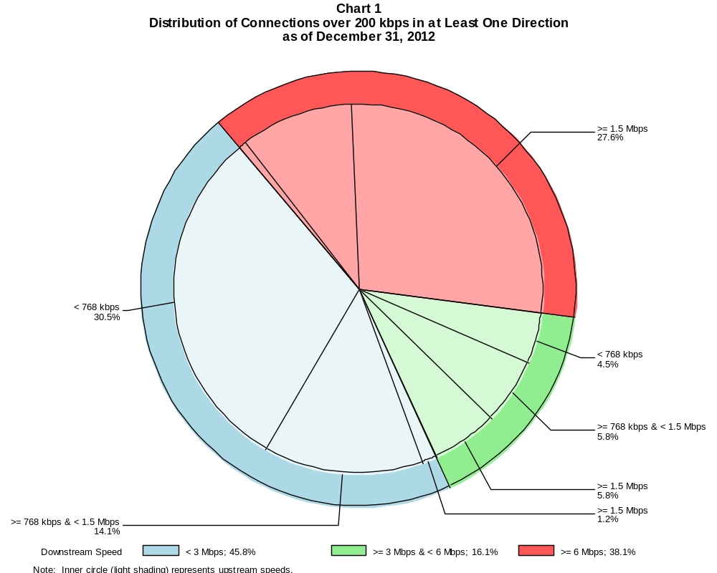

Connections over 200 kbps in at Least One Direction (in thousands)

 | Downstream Speed
Upstream Speed | Less than 3 Mbps | At least 3 Mbps  and less than 6 Mbps | At least 6 Mbps | Total
Less than 768 kbps | 79,854 | 11,662 | 1,729 | 93,245
At least 768 kbps & Less than 1.5 Mbps | 36,807 | 15,109 | 25,759 | 77,674
At least 1.5 Mbps | 3,207 | 15,281 | 72,324 | 90,812
Total | 119,868 | 42,052 | 99,812 | 261,731

Percentages

Less than 768 kbps | 30.5 | 4.5 | 0.7 | 35.6
At least 768 kbps & Less than 1.5 Mbps | 14.1 | 5.8 | 9.8 | 29.7
At least 1.5 Mbps | 1.2 | 5.8 | 27.6 | 34.7
Total | 45.8 | 16.1 | 38.1 | 100.0

Note: Figures may not sum to totals due to rounding.
Source: FCC Form 477, Part I.

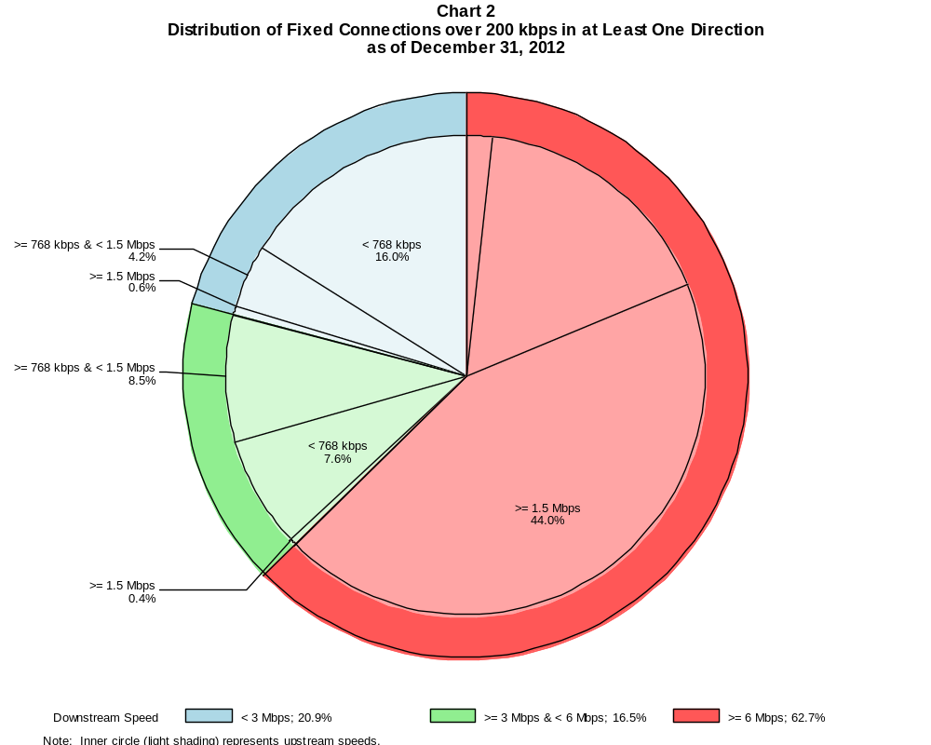

Fixed Connections over 200 kbps in at Least One Direction (in thousands)

 | Downstream Speed
Upstream Speed | Less than 3 Mbps | At least 3 Mbps  and less than 6 Mbps | At least 6 Mbps | Total
Less than 768 kbps | 14,830 | 6,990 | 1,663 | 23,483
At least 768 kbps & Less than 1.5 Mbps | 3,904 | 7,850 | 15,652 | 27,407
At least 1.5 Mbps | 583 | 406 | 40,688 | 41,677
Total | 19,318 | 15,246 | 58,002 | 92,566

Percentages

Less than 768 kbps | 16.0 | 7.6 | 1.8 | 25.4
At least 768 kbps & Less than 1.5 Mbps | 4.2 | 8.5 | 16.9 | 29.6
At least 1.5 Mbps | 0.6 | 0.4 | 44.0 | 45.0
Total | 20.9 | 16.5 | 62.7 | 100.0

Note: Figures may not sum to totals due to rounding.
Source: FCC Form 477, Part I.

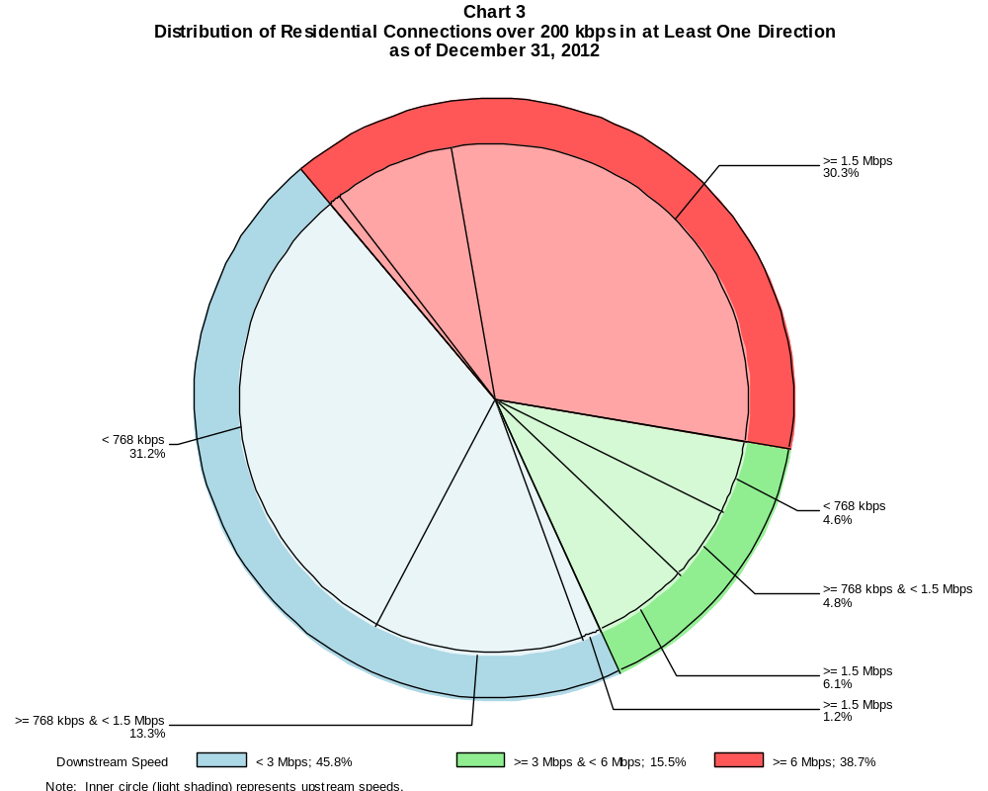

Residential Connections over 200 kbps in at Least One Direction (in thousands)

 | Downstream Speed
Upstream Speed | Less than 3 Mbps | At least 3 Mbps  and less than 6 Mbps | At least 6 Mbps | Total
Less than 768 kbps | 67,248 | 10,006 | 1,650 | 78,905
At least 768 kbps & Less than 1.5 Mbps | 28,652 | 10,249 | 16,421 | 55,322
At least 1.5 Mbps | 2,692 | 13,168 | 65,354 | 81,214
Total | 98,592 | 33,423 | 83,425 | 215,441

Percentages

Less than 768 kbps | 31.2 | 4.6 | 0.8 | 36.6
At least 768 kbps & Less than 1.5 Mbps | 13.3 | 4.8 | 7.6 | 25.7
At least 1.5 Mbps | 1.2 | 6.1 | 30.3 | 37.7
Total | 45.8 | 15.5 | 38.7 | 100.0

Note: Figures may not sum to totals due to rounding.
Source: FCC Form 477, Parts I and VI.

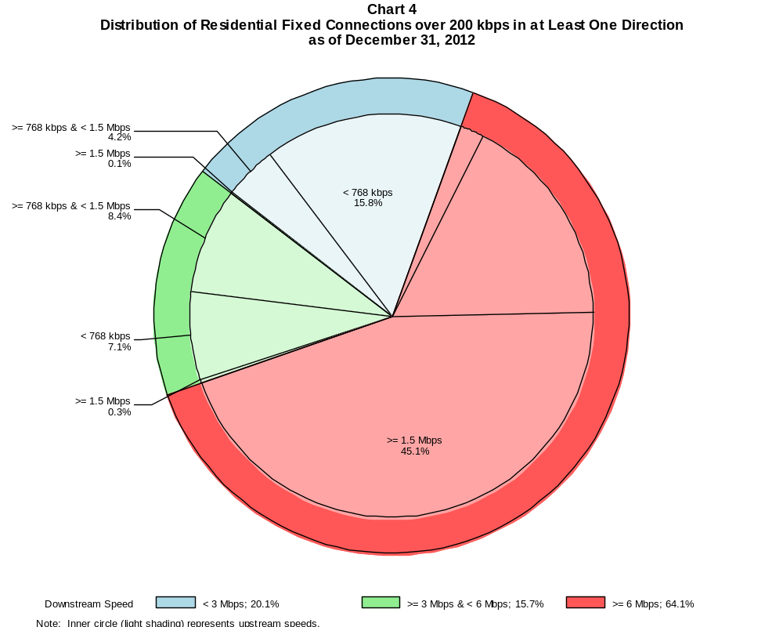

Residential Fixed Connections over 200 kbps in at Least One Direction (in thousands)

 | Downstream Speed
Upstream Speed | Less than 3 Mbps | At least 3 Mbps  and less than 6 Mbps | At least 6 Mbps | Total
Less than 768 kbps | 13,341 | 5,982 | 1,591 | 20,914
At least 768 kbps & Less than 1.5 Mbps | 3,564 | 7,058 | 14,490 | 25,113
At least 1.5 Mbps | 93 | 232 | 38,068 | 38,394
Total | 16,999 | 13,273 | 54,149 | 84,421

Percentages

Less than 768 kbps | 15.8 | 7.1 | 1.9 | 24.8
At least 768 kbps & Less than 1.5 Mbps | 4.2 | 8.4 | 17.2 | 29.7
At least 1.5 Mbps | 0.1 | 0.3 | 45.1 | 45.5
Total | 20.1 | 15.7 | 64.1 | 100.0

Note: Figures may not sum to totals due to rounding.
Source: FCC Form 477, Part VI.

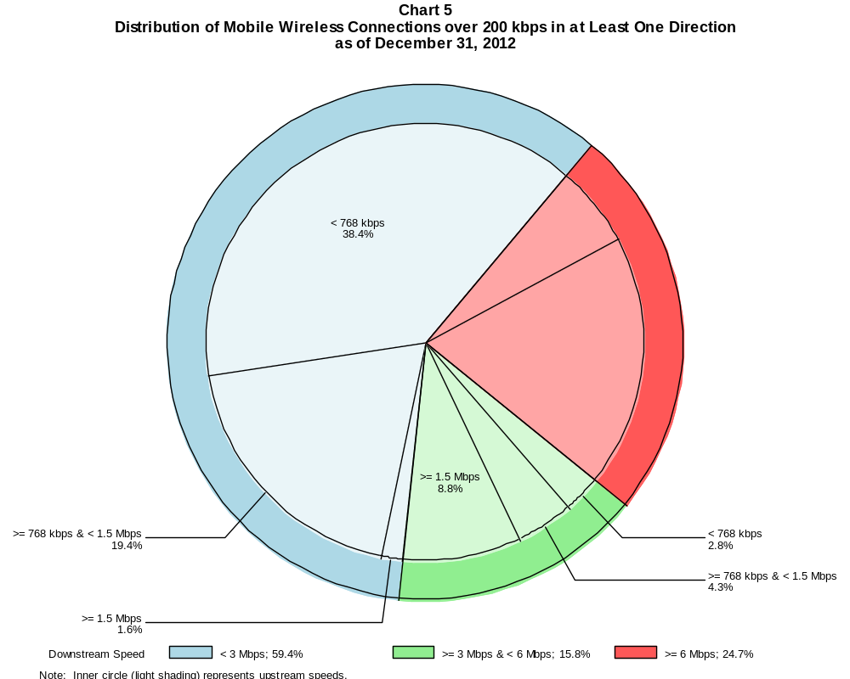

Mobile Wireless Connections over 200 kbps in at Least One Direction (in thousands)

 | Downstream Speed
Upstream Speed | Less than 3 Mbps | At least 3 Mbps  and less than 6 Mbps | At least 6 Mbps | Total
Less than 768 kbps | 65,024 | 4,672 | 67 | 69,762
At least 768 kbps & Less than 1.5 Mbps | 32,902 | 7,258 | 10,107 | 50,267
At least 1.5 Mbps | 2,624 | 14,875 | 31,636 | 49,135
Total | 100,550 | 26,805 | 41,810 | 169,165

Percentages

Less than 768 kbps | 38.4 | 2.8 | 0.0 | 41.2
At least 768 kbps & Less than 1.5 Mbps | 19.4 | 4.3 | 6.0 | 29.7
At least 1.5 Mbps | 1.6 | 8.8 | 18.7 | 29.0
Total | 59.4 | 15.8 | 24.7 | 100.0

Note: Figures may not sum to totals due to rounding.
Source: FCC Form 477, Part I.

Table 5
Connections over 200 kbps in at Least One Direction by Technology 2008-2012
(In thousands)

 | 2008 | 2009 |  | 2010 |  | 2011 |  | 2012
Technology | Dec | Jun | Dec | Jun | Dec | Jun | Dec | Jun | Dec
Total | 102,239 | 119,433 | 136,294 | 157,017 | 182,065 | 206,131 | 230,394 | 243,397 | 261,731
Total Fixed | 75,707 | 77,997 | 79,994 | 81,764 | 84,521 | 86,575 | 88,327 | 89,966 | 92,566
aDSL | 30,198 | 30,631 | 30,987 | 30,759 | 31,470 | 31,611 | 31,341 | 31,194 | 31,010
sDSL | 241 | 217 | 225 | 191 | 167 | 159 | 148 | 139 | 132
Other Wireline¹ | 709 | 689 | 719 | 755 | 795 | 778 | 795 | 770 | 822
Cable Modem | 40,251 | 41,434 | 42,439 | 43,923 | 45,334 | 46,698 | 48,263 | 49,663 | 51,649
FTTP² | 2,884 | 3,548 | 3,980 | 4,441 | 4,993 | 5,477 | 5,898 | 6,300 | 6,728
Satellite | 938 | 990 | 1,116 | 1,144 | 1,176 | 1,204 | 1,190 | 1,217 | 1,454
Fixed Wireless | 485 | 488 | 527 | 551 | 587 | 649 | 693 | 682 | 771
Mobile Wireless³ | 26,532 | 41,436 | 56,300 | 75,253 | 97,544 | 119,556 | 142,066 | 153,432 | 169,165

¹ Power Line and Other are summarized with Other Wireline to maintain firm confidentiality. See Technical Notes at the end of the report for a description of
Form 477 technology categories and other reporting requirements.
² Fiber to the premises.

Note: Some historical data have been revised. Figures may not sum to totals due to rounding.
Source: FCC Form 477, Part I.

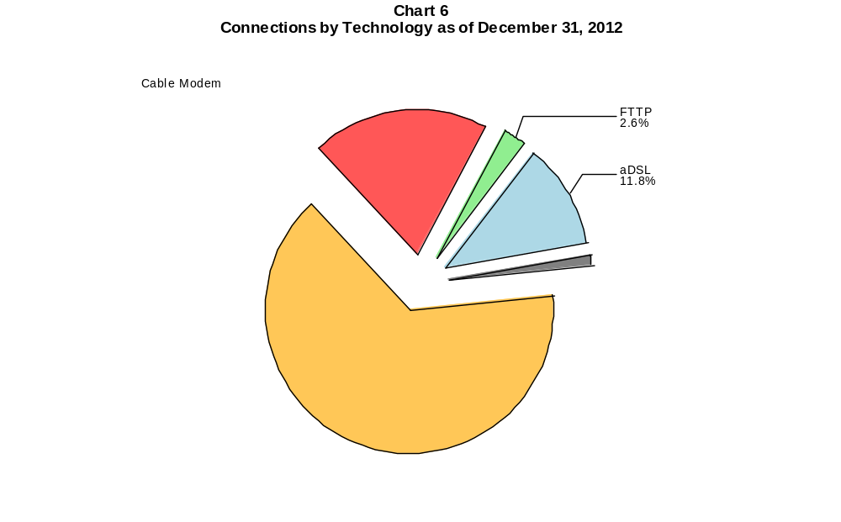

Table 6
Residential Connections over 200 kbps in at Least One Direction by Technology 2008-2012
(In thousands)

 | 2008 | 2009 |  | 2010 |  | 2011 |  | 2012
Technology | Dec | Jun | Dec | Jun | Dec | Jun | Dec | Jun | Dec
Total | 88,190 | 103,300 | 117,089 | 132,567 | 149,441 | 171,773 | 186,709 | 196,702 | 215,441
Total Fixed | 69,047 | 71,509 | 73,394 | 75,251 | 76,918 | 78,906 | 80,716 | 82,236 | 84,421
aDSL | 26,488 | 27,047 | 27,402 | 27,488 | 27,467 | 27,754 | 27,767 | 27,652 | 27,426
sDSL | 74 | 71 | 85 | 65 | 53 | 52 | 54 | 49 | 50
Other Wireline¹ | 47 | 49 | 56 | 61 | 76 | 45 | 40 | 14 | 35
Cable Modem | 38,681 | 39,909 | 40,872 | 42,178 | 43,295 | 44,480 | 45,832 | 47,033 | 48,719
FTTP² | 2,717 | 3,348 | 3,758 | 4,185 | 4,704 | 5,118 | 5,521 | 5,892 | 6,265
Satellite | 630 | 668 | 767 | 787 | 811 | 885 | 886 | 998 | 1,242
Fixed Wireless | 410 | 417 | 454 | 486 | 513 | 572 | 616 | 599 | 683
Mobile Wireless³ | 19,142 | 31,791 | 43,695 | 57,316 | 72,523 | 92,867 | 105,993 | 114,466 | 131,019

¹ Power Line and Other are summarized with Other Wireline to maintain firm confidentiality. See Technical Notes at the end of the report for a description of
Form 477 technology categories and other reporting requirements.
² Fiber to the premises.

Note: Some historical data have been revised. Figures may not sum to totals due to rounding.
Source: FCC Form 477, Part I.

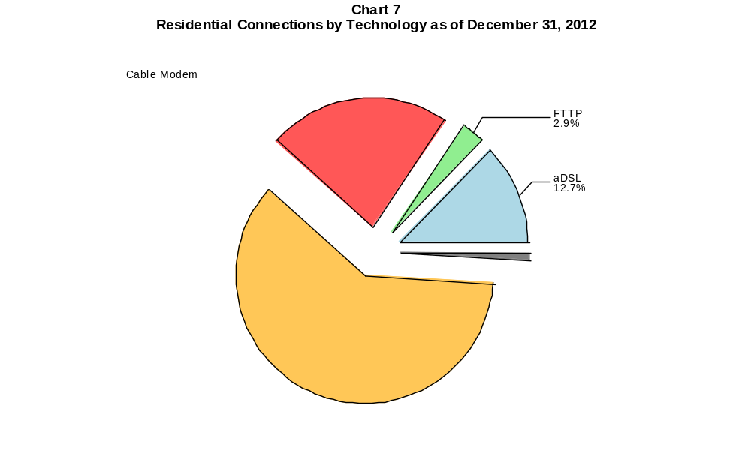

Table 7
Connections at Least 3 Mbps Downstream and 768 kbps Upstream by Technology 2008-2012
(In thousands)

 | 2008 | 2009 |  | 2010 |  | 2011 |  | 2012
Technology | Dec | Jun | Dec | Jun | Dec | Jun | Dec | Jun | Dec
Total | 31,120 | 33,332 | 40,669 | 45,552 | 55,110 | 64,819 | 82,019 | 100,277 | 128,472
Total Fixed | 30,987 | 33,108 | 38,963 | 41,364 | 44,694 | 48,577 | 51,101 | 57,252 | 64,596
aDSL | 5,403 | 5,614 | 6,389 | 6,275 | 7,302 | 8,909 | 10,355 | 12,884 | 13,049
sDSL | 5 | 9 | 19 | 13 | 14 | 16 | 26 | 30 | 33
Other Wireline¹ | 122 | 129 | 150 | 177 | 211 | 204 | 228 | 239 | 279
Cable Modem | 22,708 | 23,958 | 28,583 | 30,616 | 32,338 | 34,113 | 34,699 | 37,798 | 44,134
FTTP² | 2,694 | 3,333 | 3,739 | 4,192 | 4,725 | 5,188 | 5,606 | 6,001 | 6,425
Satellite | # | # | # | # | # | # | # | 87 | 394
Fixed Wireless | 54 | 64 | 82 | 92 | 105 | 145 | 186 | 214 | 282
Mobile Wireless | 133 | 224 | 1,706 | 4,188 | 10,416 | 16,242 | 30,918 | 43,025 | 63,876

# = Rounds to Zero.
¹ Power Line and Other are summarized with Other Wireline to maintain firm confidentiality. See Technical Notes at the end of the report for a description of
Form 477 technology categories and other reporting requirements.
² Fiber to the premises.
Note: Some historical data have been revised. Figures may not sum to totals due to rounding.
Source: FCC Form 477, Part I.

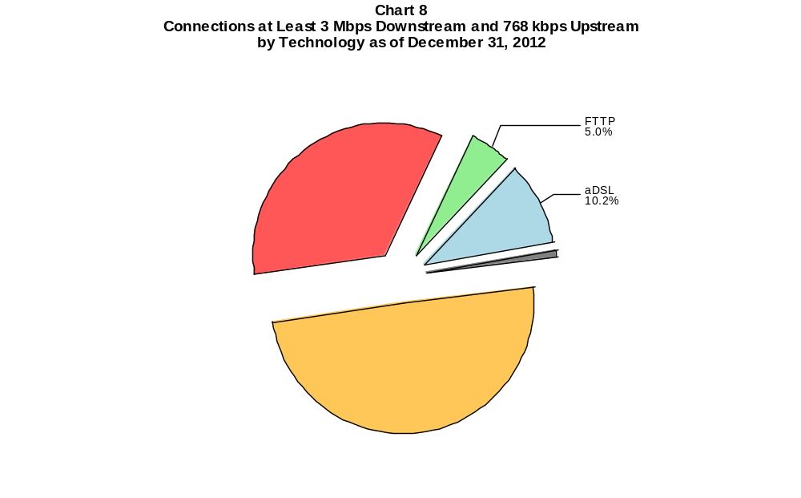

Table 8
Residential Connections at Least 3 Mbps Downstream and 768 kbps Upstream by Technology 2008-2012
(In thousands)

 | 2008 | 2009 |  | 2010 |  | 2011 |  | 2012
Technology | Dec | Jun | Dec | Jun | Dec | Jun | Dec | Jun | Dec
Total | 29,127 | 31,356 | 38,426 | 42,243 | 47,632 | 51,783 | 63,740 | 78,618 | 105,192
Total Fixed | 29,013 | 31,161 | 36,844 | 39,037 | 41,769 | 45,263 | 47,432 | 53,078 | 59,849
aDSL | 4,613 | 4,895 | 5,633 | 5,557 | 6,421 | 7,909 | 9,278 | 11,572 | 11,609
sDSL | 1 | 2 | 10 | 2 | 2 | 4 | 12 | 12 | 13
Other Wireline¹ | 11 | 12 | 19 | 20 | 36 | 15 | 16 | 7 | 21
Cable Modem | 21,776 | 23,025 | 27,548 | 29,398 | 30,742 | 32,321 | 32,693 | 35,583 | 41,563
FTTP² | 2,571 | 3,177 | 3,566 | 3,982 | 4,482 | 4,894 | 5,271 | 5,632 | 6,008
Satellite | 0 | 0 | 0 | 0 | 0 | 0 | # | 86 | 393
Fixed Wireless | 42 | 50 | 68 | 77 | 86 | 121 | 161 | 185 | 243
Mobile Wireless | 114 | 196 | 1,582 | 3,206 | 5,863 | 6,520 | 16,309 | 25,539 | 45,342

# = Rounds to Zero.
¹ Power Line and Other are summarized with Other Wireline to maintain firm confidentiality. See Technical Notes at the end of the report for a description of
Form 477 technology categories and other reporting requirements.
² Fiber to the premises.
Note: Some historical data have been revised. Figures may not sum to totals due to rounding.
Source: FCC Form 477, Part I.

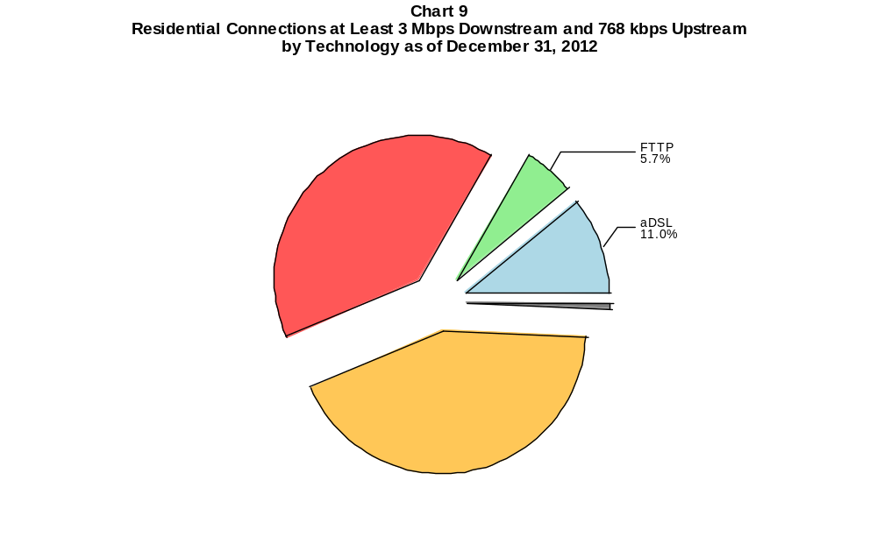

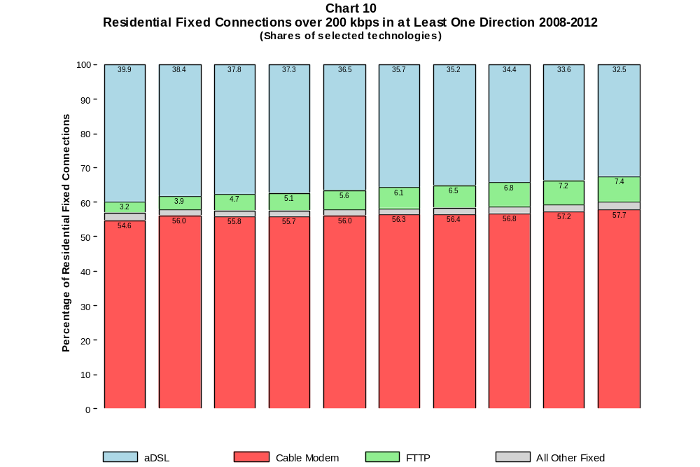

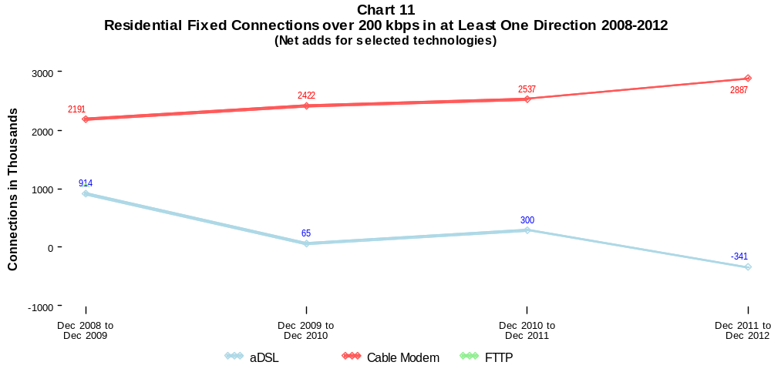

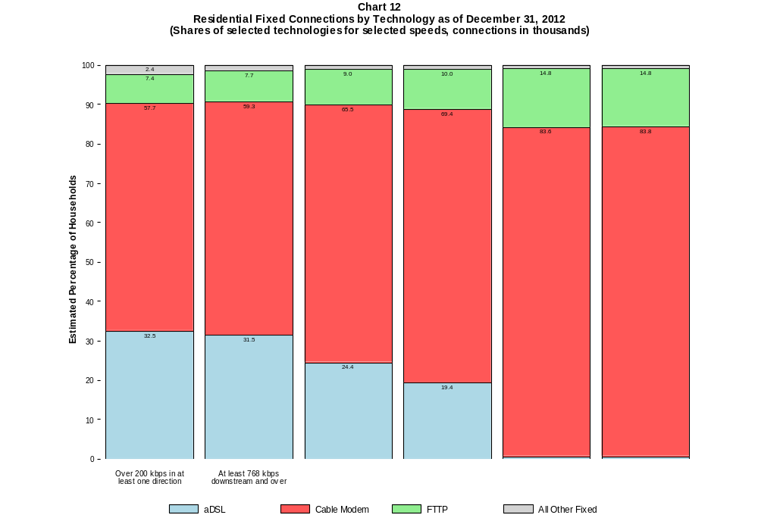

Table 9
Residential Connections by Technology and Speed (BTOP/BIP Definition)
as of December 31, 2012
(In thousands)

Technology | At Most  200 kbps  Upstream or  less than  768 kbps  Downstream | Over  200 kbps  Upstream and  at least  768 kbps  Downstream | Total
aDSL | 1,714 | 25,712 | 27,426
sDSL | 10 | 40 | 50
Other Wireline | 3 | 33 | 35
Cable Modem | 281 | 48,438 | 48,719
FTTP | 12 | 6,253 | 6,265
Satellite | 602 | 640 | 1,242
Fixed Wireless | 88 | 595 | 683
Mobile Wireless | 35,160 | 95,859 | 131,019
Total | 37,871 | 177,570 | 215,441

# = Rounds to Zero. Power Line and Other are combined with Other Wireline to maintain firm confidentiality.
Note: Figures may not sum to totals due to rounding.
Source: FCC Form 477, Parts I and VI.

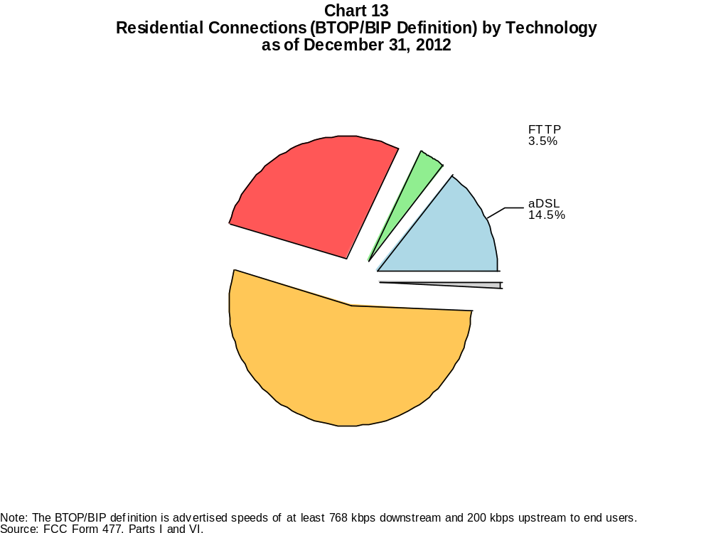

Table 10
Connections by Downstream Speed Tier and Technology as of December 31, 2012
(In thousands)

 | Downstream Speed
Technology | Greater than 200  kbps and less than  768 kbps | At least 768 kbps  and less than  1.5 Mbps | At least 1.5 Mbps  and less than  3 Mbps | At least 3 Mbps  and less than  6 Mbps | At least 6 Mbps  and less than  10 Mbps | At least 10 Mbps  and less than  25 Mbps | At least 25 Mbps  and less than  100 Mbps | At least 100 Mbps | Total
aDSL | 1,497 | 3,936 | 6,856 | 10,222 | 5,074 | 3,290 | 134 | # | 31,010
sDSL | 30 | 45 | 24 | * | * | * | 3 | # | 132
Other Wireline | 44 | 71 | 428 | 113 | 28 | 59 | 45 | 33 | 822
Cable Modem | 141 | 1,009 | 3,513 | 4,374 | 1,520 | 31,079 | 9,930 | 86 | 51,649
FTTP | 14 | 83 | 116 | 248 | 172 | 4,262 | 1,751 | 80 | 6,728
Satellite | 282 | 474 | 295 | * | * | * | 0 | 0 | 1,454
Fixed Wireless | 80 | 173 | 205 | 214 | 59 | 36 | 2 | 1 | 771
Mobile Wireless | 41,667 | 10,232 | 48,651 | 26,805 | 33,159 | 97 | 8,554 | 0 | 169,165
Total | 43,756 | 16,024 | 60,089 | 42,052 | 40,016 | 39,177 | 20,418 | 201 | 261,731

Percentages

aDSL | 0.6 | 1.5 | 2.6 | 3.9 | 1.9 | 1.3 | 0.1 | 0.0 | 11.8
sDSL | 0.0 | 0.0 | 0.0 | * | * | * | 0.0 | 0.0 | 0.1
Other Wireline | 0.0 | 0.0 | 0.2 | 0.0 | 0.0 | 0.0 | 0.0 | 0.0 | 0.3
Cable Modem | 0.1 | 0.4 | 1.3 | 1.7 | 0.6 | 11.9 | 3.8 | 0.0 | 19.7
FTTP | 0.0 | 0.0 | 0.0 | 0.1 | 0.1 | 1.6 | 0.7 | 0.0 | 2.6
Satellite | 0.1 | 0.2 | 0.1 | * | * | * | 0.0 | 0.0 | 0.6
Fixed Wireless | 0.0 | 0.1 | 0.1 | 0.1 | 0.0 | 0.0 | 0.0 | 0.0 | 0.3
Mobile Wireless | 15.9 | 3.9 | 18.6 | 10.2 | 12.7 | 0.0 | 3.3 | 0.0 | 64.6
Total | 16.7 | 6.1 | 23.0 | 16.1 | 15.3 | 15.0 | 7.8 | 0.1 | 100.0

# = Rounds to Zero. Power Line and Other are combined with Other Wireline to maintain firm confidentiality.
* = Data withheld to maintain firm confidentiality.
Note: Figures may not sum to totals due to rounding.
Source: FCC Form 477, Part I.

Table 11
Residential Connections by Downstream Speed Tier and Technology as of December 31, 2012
(In thousands)

 | Downstream Speed
Technology | Greater than 200  kbps and less than  768 kbps | At least 768 kbps  and less than  1.5 Mbps | At least 1.5 Mbps  and less than  3 Mbps | At least 3 Mbps  and less than  6 Mbps | At least 6 Mbps  and less than  10 Mbps | At least 10 Mbps  and less than  25 Mbps | At least 25 Mbps  and less than  100 Mbps | At least 100 Mbps | Total
aDSL | 1,389 | 3,577 | 6,006 | 8,753 | 4,536 | 3,040 | 125 | # | 27,426
sDSL | 10 | 24 | 3 | * | * | * | 2 | 0 | 50
Other Wireline | 3 | 6 | 6 | 5 | 3 | 11 | 1 | 1 | 35
Cable Modem | 127 | 982 | 3,434 | 4,054 | 1,180 | 29,434 | 9,444 | 63 | 48,719
FTTP | 12 | 74 | 88 | 216 | 159 | 4,036 | 1,648 | 32 | 6,265
Satellite | 151 | 437 | 258 | * | * | * | 0 | 0 | 1,242
Fixed Wireless | 74 | 157 | 182 | 188 | 51 | 30 | 1 | 1 | 683
Mobile Wireless | 33,441 | 9,197 | 38,955 | 20,150 | 21,184 | 85 | 8,007 | 0 | 131,019
Total | 35,206 | 14,454 | 48,932 | 33,423 | 27,114 | 36,986 | 19,228 | 97 | 215,441

Percentages

aDSL | 0.6 | 1.7 | 2.8 | 4.1 | 2.1 | 1.4 | 0.1 | 0.0 | 12.7
sDSL | 0.0 | 0.0 | 0.0 | * | * | * | 0.0 | 0.0 | 0.0
Other Wireline | 0.0 | 0.0 | 0.0 | 0.0 | 0.0 | 0.0 | 0.0 | 0.0 | 0.0
Cable Modem | 0.1 | 0.5 | 1.6 | 1.9 | 0.5 | 13.7 | 4.4 | 0.0 | 22.6
FTTP | 0.0 | 0.0 | 0.0 | 0.1 | 0.1 | 1.9 | 0.8 | 0.0 | 2.9
Satellite | 0.1 | 0.2 | 0.1 | * | * | * | 0.0 | 0.0 | 0.6
Fixed Wireless | 0.0 | 0.1 | 0.1 | 0.1 | 0.0 | 0.0 | 0.0 | 0.0 | 0.3
Mobile Wireless | 15.5 | 4.3 | 18.1 | 9.4 | 9.8 | 0.0 | 3.7 | 0.0 | 60.8
Total | 16.3 | 6.7 | 22.7 | 15.5 | 12.6 | 17.2 | 8.9 | 0.0 | 100.0

# = Rounds to Zero. Power Line and Other are combined with Other Wireline to maintain firm confidentiality.
* = Data withheld to maintain firm confidentiality.
Note: Figures may not sum to totals due to rounding.
Source: FCC Form 477, Part I.

Table 12
Nationwide Number of Providers of Connections over 200 kbps in at Least One Direction
by Technology 2008-2012

 | 2008 | 2009 |  | 2010 |  | 2011 |  | 2012
Technology | Dec | Jun | Dec | Jun | Dec | Jun | Dec | Jun | Dec
aDSL | 881 | 876 | 862 | 875 | 865 | 867 | 868 | 861 | 865
sDSL | 264 | 257 | 261 | 251 | 247 | 252 | 255 | 250 | 254
Other Wireline | 292 | 283 | 274 | 267 | 270 | 265 | 275 | 258 | 261
Cable Modem | 342 | 351 | 345 | 345 | 357 | 400 | 405 | 400 | 404
FTTP | 432 | 462 | 485 | 510 | 545 | 579 | 621 | 642 | 665
Satellite | 5 | 4 | 4 | 4 | 4 | 5 | 6 | 5 | 6
Fixed Wireless | 620 | 621 | 607 | 625 | 646 | 672 | 712 | 710 | 757
Mobile Wireless | 47 | 48 | 51 | 55 | 57 | 64 | 69 | 67 | 69
Power Line and Other | 5 | 6 | 6 | 5 | 7 | 4 | 5 | * | *
Total | 1,562 | 1,551 | 1,526 | 1,536 | 1,566 | 1,624 | 1,686 | 1,669 | 1,712

Note: Some historical data have been revised. Multiple Form 477 filers within a holding company structure count as one provider. * = 1-3 providers.
Source: FCC Form 477, Part I.

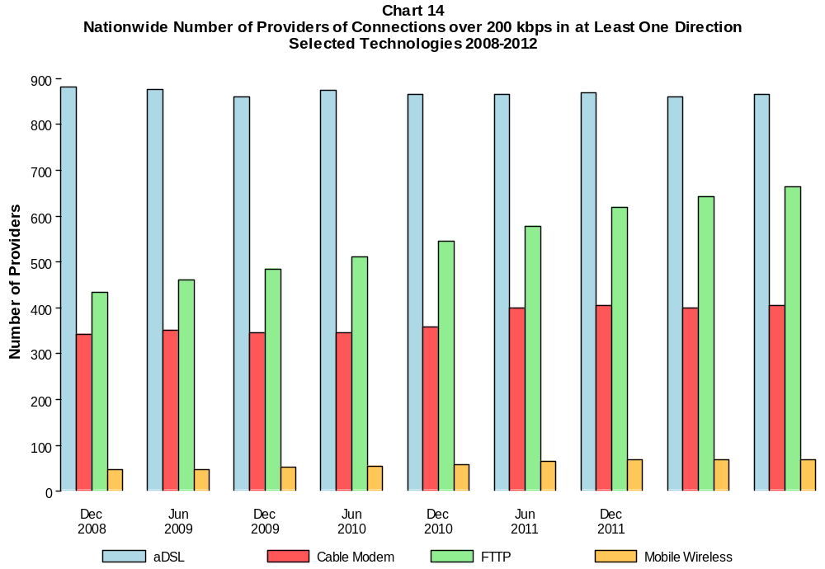

Table 13
Residential Fixed Connections at Least 3 Mbps Downstream / 768 kbps Upstream
and Households by State as of December 31, 2012
(Connections and households, in thousands)
State | Connections | Households | Subscribership  Ratio
Alabama | 637 | 1,907 | 0.33
Alaska | 99 | 266 | 0.37
American Samoa | 0 | 11 | 0.00
Arizona | 1,377 | 2,457 | 0.56
Arkansas | 331 | 1,165 | 0.28
California | 6,054 | 12,812 | 0.47
Colorado | 1,289 | 2,029 | 0.64
Connecticut | 841 | 1,381 | 0.61
Delaware | 245 | 351 | 0.70
District of Columbia | 186 | 274 | 0.68
Florida | 4,237 | 7,631 | 0.56
Georgia | 1,655 | 3,688 | 0.45
Guam | * | 51 | *
Hawaii | * | 465 | *
Idaho | 186 | 596 | 0.31
Illinois | 2,206 | 4,863 | 0.45
Indiana | 1,012 | 2,529 | 0.40
Iowa | 326 | 1,231 | 0.26
Kansas | 488 | 1,124 | 0.43
Kentucky | 762 | 1,742 | 0.44
Louisiana | 580 | 1,742 | 0.33
Maine | 353 | 559 | 0.63
Maryland | 1,541 | 2,194 | 0.70
Massachusetts | 1,971 | 2,567 | 0.77
Michigan | 1,851 | 3,861 | 0.48
Minnesota | 1,034 | 2,115 | 0.49
Mississippi | 265 | 1,123 | 0.24
Missouri | 898 | 2,400 | 0.37
Montana | 173 | 417 | 0.41
Nebraska | 336 | 730 | 0.46
Nevada | 530 | 1,045 | 0.51
New Hampshire | 380 | 523 | 0.73
New Jersey | 2,463 | 3,238 | 0.76
New Mexico | 324 | 809 | 0.40
New York | 4,494 | 7,350 | 0.61
North Carolina | 2,024 | 3,855 | 0.52
North Dakota | 132 | 286 | 0.46
Northern Mariana Isl | * | 21 | *
Ohio | 2,323 | 4,609 | 0.50
Oklahoma | 464 | 1,486 | 0.31
Oregon | 862 | 1,551 | 0.56
Pennsylvania | 3,002 | 5,046 | 0.59
Puerto Rico | * | 1,230 | *
Rhode Island | 297 | 413 | 0.72
South Carolina | 876 | 1,848 | 0.47
South Dakota | 170 | 328 | 0.52
Tennessee | 1,058 | 2,542 | 0.42
Texas | 3,338 | 9,241 | 0.36
Utah | 538 | 909 | 0.59
Vermont | 167 | 257 | 0.65
Virgin Islands | 5 | 56 | 0.08
Virginia | 1,938 | 3,124 | 0.62
Washington | 1,596 | 2,691 | 0.59
West Virginia | 262 | 766 | 0.34
Wisconsin | 1,074 | 2,302 | 0.47
Wyoming | 109 | 232 | 0.47
Total | 59,849 | 120,039 | 0.50

# = Rounds to Zero; * = Data withheld to maintain firm confidentiality.
Note: Figures may not sum to totals due to rounding.
Sources: FCC Form 477, Part VI (Connections); Geolytics 2012 Block-Level Estimates (Households for U.S. and District of Columbia);
Census 2010 (Housing Units for Puerto Rico, American Samoa, Guam, Northern Mariana Islands and U.S. Virgin Islands).

Table 14
Residential Fixed Connections and Households by State as of December 31, 2012
(Connections over 200 kbps in at least one direction and households, in thousands)

State | Connections | Households | Subscribership  Ratio
Alabama | 1,112 | 1,907 | 0.58
Alaska | 181 | 266 | 0.68
American Samoa | * | 11 | *
Arizona | 1,775 | 2,457 | 0.72
Arkansas | 635 | 1,165 | 0.55
California | 9,778 | 12,812 | 0.76
Colorado | 1,557 | 2,029 | 0.77
Connecticut | 1,085 | 1,381 | 0.79
Delaware | 273 | 351 | 0.78
District of Columbia | 203 | 274 | 0.74
Florida | 5,768 | 7,631 | 0.76
Georgia | 2,430 | 3,688 | 0.66
Guam | * | 51 | *
Hawaii | 378 | 465 | 0.81
Idaho | 382 | 596 | 0.64
Illinois | 3,366 | 4,863 | 0.69
Indiana | 1,637 | 2,529 | 0.65
Iowa | 827 | 1,231 | 0.67
Kansas | 775 | 1,124 | 0.69
Kentucky | 1,113 | 1,742 | 0.64
Louisiana | 1,065 | 1,742 | 0.61
Maine | 414 | 559 | 0.74
Maryland | 1,660 | 2,194 | 0.76
Massachusetts | 2,086 | 2,567 | 0.81
Michigan | 2,574 | 3,861 | 0.67
Minnesota | 1,483 | 2,115 | 0.70
Mississippi | 562 | 1,123 | 0.50
Missouri | 1,519 | 2,400 | 0.63
Montana | 278 | 417 | 0.67
Nebraska | 503 | 730 | 0.69
Nevada | 704 | 1,045 | 0.67
New Hampshire | 425 | 523 | 0.81
New Jersey | 2,623 | 3,238 | 0.81
New Mexico | 483 | 809 | 0.60
New York | 5,753 | 7,350 | 0.78
North Carolina | 2,755 | 3,855 | 0.71
North Dakota | 206 | 286 | 0.72
Northern Mariana Isl | * | 21 | *
Ohio | 3,238 | 4,609 | 0.70
Oklahoma | 877 | 1,486 | 0.59
Oregon | 1,095 | 1,551 | 0.71
Pennsylvania | 3,667 | 5,046 | 0.73
Puerto Rico | 540 | 1,230 | 0.44
Rhode Island | 311 | 413 | 0.75
South Carolina | 1,218 | 1,848 | 0.66
South Dakota | 225 | 328 | 0.69
Tennessee | 1,500 | 2,542 | 0.59
Texas | 6,058 | 9,241 | 0.66
Utah | 676 | 909 | 0.74
Vermont | 201 | 257 | 0.78
Virgin Islands | 23 | 56 | 0.40
Virginia | 2,219 | 3,124 | 0.71
Washington | 1,963 | 2,691 | 0.73
West Virginia | 470 | 766 | 0.61
Wisconsin | 1,576 | 2,302 | 0.68
Wyoming | 157 | 232 | 0.68
Total | 84,421 | 120,039 | 0.70

# = Rounds to Zero; * = Data withheld to maintain firm confidentiality.
Note: Figures may not sum to totals due to rounding.
Sources: FCC Form 477, Part VI (Connections); Geolytics 2012 Block-Level Estimates (Households for U.S. and District of Columbia);
Census 2010 (Housing Units for Puerto Rico, American Samoa, Guam, Northern Mariana Islands and U.S. Virgin Islands).

Table 15
Connections by Type of End User by State as of December 31, 2012
(Connections over 200 kbps in at least one direction, in thousands)

 | Connections |  | Percentages
State | Residential | Business | Residential | Business | Total
Alabama | 2,983 | 421 | 87.6 | 12.4 | 3,404
Alaska | 531 | 91 | 85.4 | 14.6 | 622
American Samoa | * | * | * | * | *
Arizona | 4,272 | 715 | 85.7 | 14.3 | 4,987
Arkansas | 1,846 | 272 | 87.1 | 12.9 | 2,118
California | 26,841 | 5,904 | 82.0 | 18.0 | 32,745
Colorado | 3,825 | 838 | 82.0 | 18.0 | 4,664
Connecticut | 2,668 | 567 | 82.5 | 17.5 | 3,235
Delaware | 662 | 130 | 83.6 | 16.4 | 792
District of Columbia | 611 | 619 | 49.7 | 50.3 | 1,230
Florida | 13,979 | 3,109 | 81.8 | 18.2 | 17,088
Georgia | 6,691 | 1,438 | 82.3 | 17.7 | 8,129
Guam | 62 | 19 | 76.2 | 23.8 | 82
Hawaii | 1,043 | 174 | 85.7 | 14.3 | 1,217
Idaho | 980 | 195 | 83.4 | 16.6 | 1,176
Illinois | 8,759 | 2,032 | 81.2 | 18.8 | 10,792
Indiana | 4,048 | 664 | 85.9 | 14.1 | 4,712
Iowa | 1,768 | 318 | 84.8 | 15.2 | 2,086
Kansas | 1,811 | 579 | 75.8 | 24.2 | 2,390
Kentucky | 2,743 | 499 | 84.6 | 15.4 | 3,241
Louisiana | 3,175 | 512 | 86.1 | 13.9 | 3,687
Maine | 798 | 121 | 86.9 | 13.1 | 918
Maryland | 4,327 | 872 | 83.2 | 16.8 | 5,199
Massachusetts | 4,923 | 1,036 | 82.6 | 17.4 | 5,959
Michigan | 6,139 | 1,713 | 78.2 | 21.8 | 7,852
Minnesota | 3,499 | 900 | 79.5 | 20.5 | 4,400
Mississippi | 1,819 | 240 | 88.3 | 11.7 | 2,059
Missouri | 3,759 | 934 | 80.1 | 19.9 | 4,692
Montana | 655 | 93 | 87.6 | 12.4 | 748
Nebraska | 1,142 | 259 | 81.5 | 18.5 | 1,401
Nevada | 1,986 | 377 | 84.0 | 16.0 | 2,363
New Hampshire | 914 | 154 | 85.5 | 14.5 | 1,068
New Jersey | 6,805 | 1,433 | 82.6 | 17.4 | 8,238
New Mexico | 1,237 | 195 | 86.4 | 13.6 | 1,432
New York | 14,370 | 3,064 | 82.4 | 17.6 | 17,434
North Carolina | 6,200 | 1,350 | 82.1 | 17.9 | 7,550
North Dakota | 501 | 91 | 84.6 | 15.4 | 592
Northern Mariana Isl | * | * | * | * | *
Ohio | 7,672 | 1,660 | 82.2 | 17.8 | 9,332
Oklahoma | 2,434 | 400 | 85.9 | 14.1 | 2,834
Oregon | 2,678 | 534 | 83.4 | 16.6 | 3,211
Pennsylvania | 8,685 | 1,613 | 84.3 | 15.7 | 10,298
Puerto Rico | 1,906 | 209 | 90.1 | 9.9 | 2,114
Rhode Island | 723 | 146 | 83.2 | 16.8 | 870
South Carolina | 2,833 | 451 | 86.3 | 13.7 | 3,284
South Dakota | 535 | 73 | 88.0 | 12.0 | 608
Tennessee | 4,084 | 844 | 82.9 | 17.1 | 4,929
Texas | 18,183 | 4,511 | 80.1 | 19.9 | 22,694
Utah | 1,740 | 420 | 80.6 | 19.4 | 2,160
Vermont | 404 | 75 | 84.4 | 15.6 | 479
Virgin Islands | 78 | 9 | 89.5 | 10.5 | 87
Virginia | 5,589 | 1,302 | 81.1 | 18.9 | 6,890
Washington | 4,815 | 1,170 | 80.5 | 19.5 | 5,984
West Virginia | 1,011 | 146 | 87.4 | 12.6 | 1,157
Wisconsin | 3,301 | 739 | 81.7 | 18.3 | 4,040
Wyoming | 388 | 59 | 86.9 | 13.1 | 447
Total | 215,441 | 46,290 | 82.3 | 17.7 | 261,731

# = Rounds to Zero.
* = Data withheld to maintain firm confidentiality.
Figures may not sum to totals due to rounding.
Source: FCC Form 477, Part I and VI.

Table 16
Connections by Technology by State as of December 31, 2012
(Connections over 200 kbps in at least one direction, in thousands)

State | ADSL | SDSL | Other  Wireline | Cable  Modem | Fiber | Satellite | Fixed  Wireless | Mobile  Wireless | Total
Alabama | 546 | 5 | * | 615 | 9 | * | 5 | 2,171 | 3,404
Alaska | 79 | 2 | 0 | * | 1 | * | 5 | 398 | 622
American Samoa | * | * | 0 | * | * | 0 | * | 0 | *
Arizona | 625 | # | * | 1,210 | 5 | * | 31 | 3,076 | 4,987
Arkansas | 345 | # | * | 313 | 8 | * | 4 | 1,416 | 2,118
California | 4,285 | 12 | * | 5,414 | 744 | * | 41 | 22,020 | 32,745
Colorado | * | 1 | 0 | 899 | 7 | * | 48 | 2,959 | 4,664
Connecticut | * | 1 | 0 | 761 | 5 | * | 0 | 2,046 | 3,235
Delaware | * | # | 0 | 174 | * | * | 0 | 497 | 792
District of Columbia | * | 2 | 0 | * | 18 | * | * | 997 | 1,230
Florida | 1,977 | 1 | * | 3,803 | 425 | * | 6 | 10,769 | 17,088
Georgia | 1,300 | 2 | * | 1,291 | 34 | * | 1 | 5,429 | 8,129
Guam | * | * | * | * | * | 0 | * | * | 82
Hawaii | * | * | 0 | * | 4 | * | * | 808 | 1,217
Idaho | 208 | # | * | 161 | 4 | * | 30 | 757 | 1,176
Illinois | 1,504 | 6 | * | 2,020 | 19 | * | 53 | 7,105 | 10,792
Indiana | 754 | 2 | * | 868 | 75 | * | 32 | 2,936 | 4,712
Iowa | 396 | 2 | * | 407 | 48 | * | 27 | 1,180 | 2,086
Kansas | 278 | 1 | * | 468 | 53 | * | 28 | 1,538 | 2,390
Kentucky | 507 | 3 | * | 637 | 20 | * | 11 | 2,024 | 3,241
Louisiana | 446 | 2 | * | 644 | 43 | * | 5 | 2,499 | 3,687
Maine | 140 | 4 | 0 | 297 | 5 | * | * | 460 | 918
Maryland | * | 2 | 0 | 873 | * | * | 1 | 3,404 | 5,199
Massachusetts | * | 2 | 0 | 1,503 | * | * | 2 | 3,687 | 5,959
Michigan | 907 | 6 | * | 1,756 | 11 | * | 35 | 5,046 | 7,852
Minnesota | 633 | 16 | * | 874 | 42 | * | 20 | 2,777 | 4,400
Mississippi | 313 | # | * | 273 | 2 | * | 1 | 1,427 | 2,059
Missouri | 863 | 1 | * | 688 | 17 | * | 24 | 3,025 | 4,692
Montana | 122 | 1 | 0 | 150 | 8 | * | 16 | * | 748
Nebraska | 176 | # | * | 338 | 12 | * | 16 | 847 | 1,401

Table 16 - Continued
Connections by Technology by State as of December 31, 2012
(Connections over 200 kbps in at least one direction, in thousands)

State | ADSL | SDSL | Other  Wireline | Cable  Modem | Fiber | Satellite | Fixed  Wireless | Mobile  Wireless | Total
Nevada | 255 | # | 0 | * | 4 | * | 4 | 1,594 | 2,363
New Hampshire | 91 | 1 | * | 358 | 14 | * | # | 596 | 1,068
New Jersey | 346 | 1 | 0 | 1,847 | * | * | # | 5,335 | 8,238
New Mexico | 291 | # | * | 203 | 4 | * | 17 | 899 | 1,432
New York | 777 | 7 | 0 | 4,459 | * | * | 2 | 11,084 | 17,434
North Carolina | 1,063 | 1 | * | 1,851 | 34 | * | 2 | 4,545 | 7,550
North Dakota | 73 | 2 | * | 116 | 34 | * | 6 | 356 | 592
Northern Mariana Isl | * | 0 | * | * | * | 0 | * | * | *
Ohio | 1,178 | 4 | * | 2,171 | 54 | * | 31 | 5,834 | 9,332
Oklahoma | 393 | # | * | 502 | 15 | * | 15 | 1,861 | 2,834
Oregon | 373 | 3 | * | 711 | 67 | * | 16 | 2,014 | 3,211
Pennsylvania | 1,017 | 4 | 0 | 2,286 | * | * | 4 | 6,314 | 10,298
Puerto Rico | * | 0 | 0 | * | * | * | * | 1,528 | 2,114
Rhode Island | * | # | 0 | * | * | * | * | 530 | 870
South Carolina | 477 | 5 | * | 780 | 38 | * | 1 | 1,950 | 3,284
South Dakota | 65 | * | 0 | 143 | 22 | * | 12 | * | 608
Tennessee | 607 | 1 | * | 911 | 80 | * | 5 | 3,264 | 4,929
Texas | 2,983 | 5 | * | 2,888 | 457 | * | 86 | 16,022 | 22,694
Utah | 317 | # | * | 339 | 23 | * | 45 | 1,422 | 2,160
Vermont | 98 | # | * | 113 | 6 | * | 1 | 250 | 479
Virgin Islands | * | 0 | * | * | 0 | * | * | 62 | 87
Virginia | 453 | 1 | 0 | 1,238 | * | * | 4 | 4,477 | 6,890
Washington | 598 | 2 | * | 1,400 | 68 | * | 15 | 3,850 | 5,984
West Virginia | * | * | 0 | 306 | 2 | * | 2 | 644 | 1,157
Wisconsin | 651 | 18 | * | 948 | 24 | * | 33 | 2,325 | 4,040
Wyoming | 63 | # | * | 92 | 2 | * | 11 | 268 | 447
Total | 31,010 | 132 | 822 | 51,649 | 6,728 | 1,454 | 771 | 169,165 | 261,731

# = Rounds to Zero. Power Line and Other are summarized with Other Wireline to maintain firm confidentiality.
* = Data withheld to maintain firm confidentiality.
Figures may not sum to totals due to rounding.
Source: FCC Form 477, Part I.

Table 17
Connections by Technology by State as of December 31, 2012
(Connections at least 3 Mbps downstream and 768 kbps upstream, in thousands)

State | ADSL | SDSL | Other  Wireline | Cable  Modem | Fiber | Satellite | Fixed  Wireless | Mobile  Wireless | Total
Alabama | 162 | # | 3 | 501 | 7 | * | 1 | * | 1,196
Alaska | 35 | * | 1 | * | 1 | * | * | * | 158
American Samoa | 0 | * | 0 | 0 | * | 0 | 0 | 0 | *
Arizona | * | * | 6 | 1,045 | 4 | * | 7 | * | 2,294
Arkansas | 119 | * | 2 | 223 | 5 | * | 1 | * | 507
California | 1,736 | 2 | * | 3,937 | 724 | * | 20 | 6,079 | 12,562
Colorado | * | # | 9 | 892 | 4 | * | 32 | 942 | 2,327
Connecticut | * | * | 2 | 751 | 4 | * | 0 | * | 1,437
Delaware | * | 0 | 1 | * | * | * | 0 | 155 | 419
District of Columbia | * | * | 3 | * | * | * | * | 580 | 790
Florida | 846 | # | * | 3,248 | 414 | * | 3 | 5,850 | 10,400
Georgia | 503 | # | * | 1,215 | 27 | * | # | 2,783 | 4,548
Guam | * | * | * | * | * | 0 | * | * | 24
Hawaii | * | * | # | * | 3 | * | * | * | 654
Idaho | 114 | * | 1 | 79 | 2 | * | 11 | * | 473
Illinois | 476 | 3 | * | 1,858 | 16 | * | 11 | 3,964 | 6,351
Indiana | 229 | # | * | 778 | 68 | * | 8 | 767 | 1,866
Iowa | 185 | 1 | 1 | 129 | 34 | * | 11 | * | 728
Kansas | 93 | # | * | 382 | 34 | * | 3 | 609 | 1,126
Kentucky | 230 | * | 1 | 553 | 11 | * | 3 | 474 | 1,284
Louisiana | * | 1 | 2 | 470 | 29 | * | 1 | * | 882
Maine | 99 | 1 | # | 280 | 5 | * | * | * | 493
Maryland | * | # | 6 | 857 | * | * | # | 1,771 | 3,423
Massachusetts | * | # | 10 | 1,494 | * | * | 1 | 1,882 | 4,014
Michigan | 314 | 2 | * | 1,607 | 9 | * | 16 | 1,766 | 3,740
Minnesota | 289 | 10 | * | 778 | 29 | * | 3 | 1,093 | 2,215
Mississippi | 65 | * | 1 | 211 | 1 | * | * | * | 394
Missouri | 338 | # | * | 581 | 11 | * | 4 | 1,792 | 2,749
Montana | 41 | # | 1 | * | 6 | * | 5 | * | 306
Nebraska | 103 | * | 1 | 249 | 8 | * | 2 | * | 569

Table 17 - Continued
Connections by Technology by State as of December 31, 2012
(Connections at least 3 Mbps downstream and 768 kbps upstream, in thousands)

State | ADSL | SDSL | Other  Wireline | Cable  Modem | Fiber | Satellite | Fixed  Wireless | Mobile  Wireless | Total
Nevada | 104 | * | 3 | * | 3 | * | 4 | 896 | 1,454
New Hampshire | 52 | # | 1 | 348 | 13 | * | * | 173 | 589
New Jersey | 210 | * | 12 | 1,817 | * | * | * | 1,494 | 4,196
New Mexico | 158 | # | 2 | 188 | 3 | * | 2 | * | 592
New York | 439 | 1 | 22 | 3,525 | * | * | 1 | * | 8,609
North Carolina | 402 | # | * | 1,716 | 26 | * | # | 2,186 | 4,347
North Dakota | 32 | # | 1 | 95 | 19 | * | 2 | * | 244
Northern Mariana Isl | * | 0 | 0 | 0 | * | 0 | * | 0 | *
Ohio | 531 | * | 5 | 1,870 | 50 | * | 4 | 2,044 | 4,517
Oklahoma | 124 | # | * | 344 | 11 | * | 6 | 305 | 802
Oregon | 155 | # | * | 699 | 64 | * | 9 | 624 | 1,559
Pennsylvania | 551 | * | 10 | 2,077 | * | * | 3 | 1,873 | 5,135
Puerto Rico | * | 0 | * | * | * | 0 | * | 512 | 631
Rhode Island | * | * | 1 | * | * | * | * | 278 | 598
South Carolina | 164 | * | 4 | 730 | 30 | * | # | 614 | 1,550
South Dakota | 38 | * | # | 130 | 17 | * | 2 | * | 275
Tennessee | 173 | # | * | 883 | 66 | * | # | 956 | 2,099
Texas | 1,259 | 1 | * | 1,814 | 416 | * | 46 | 9,559 | 13,165
Utah | 185 | * | 4 | 327 | 22 | * | 40 | 509 | 1,088
Vermont | 69 | * | # | 111 | 6 | * | * | * | 226
Virgin Islands | 0 | 0 | * | * | 0 | * | * | 0 | 6
Virginia | 258 | # | 9 | 1,172 | * | * | 2 | 1,439 | 3,523
Washington | 263 | * | 8 | 1,372 | 63 | * | 4 | 1,251 | 2,969
West Virginia | 18 | 0 | * | 267 | 2 | * | 2 | 67 | 362
Wisconsin | 218 | 2 | * | 886 | 17 | * | 3 | 672 | 1,811
Wyoming | 25 | * | 1 | * | 2 | * | 2 | * | 194
Total | 13,049 | 33 | 279 | 44,134 | 6,425 | 394 | 282 | 63,876 | 128,472

# = Rounds to Zero. Power Line and Other are summarized with Other Wireline to maintain firm confidentiality.
* = Data withheld to maintain firm confidentiality.
Figures may not sum to totals due to rounding.
Source: FCC Form 477, Part I.

Table 18
Percentage of Connections by Downstream Speed by State as of December 31, 2012
(Connections over 200 kbps in at least one direction)

 | Over 200 kbps Upstream and
State | % over 200 kbps  Downstream | % at least 768 kbps  Downstream | % at least 3 Mbps  Downstream | % at least 6 Mbps  Downstream | % at least 10 Mbps  Downstream
Alabama | 95.9 | 79.5 | 42.2 | 35.5 | 18.2
Alaska | 83.6 | 80.6 | 29.8 | 23.7 | 14.5
American Samoa | * | * | * | * | *
Arizona | 96.4 | 79.0 | 48.6 | 41.8 | 27.5
Arkansas | 97.0 | 84.5 | 29.0 | 21.7 | 11.8
California | 96.6 | 81.9 | 40.4 | 32.5 | 17.4
Colorado | 96.8 | 81.7 | 50.8 | 44.1 | 27.5
Connecticut | 97.2 | 80.6 | 46.2 | 39.3 | 25.5
Delaware | 96.3 | 79.2 | 54.8 | 48.5 | 31.5
District of Columbia | 95.2 | 77.4 | 67.5 | 49.5 | 18.6
Florida | 97.3 | 85.0 | 70.5 | 40.7 | 26.4
Georgia | 96.1 | 79.4 | 66.4 | 35.9 | 19.7
Guam | 100.0 | 94.3 | 29.2 | 15.9 | 10.8
Hawaii | 98.1 | 87.3 | 54.5 | 43.9 | 23.1
Idaho | 94.5 | 74.6 | 48.1 | 34.9 | 13.4
Illinois | 97.2 | 85.3 | 68.0 | 38.9 | 23.3
Indiana | 96.5 | 81.4 | 46.0 | 35.3 | 20.0
Iowa | 96.4 | 79.0 | 50.1 | 34.6 | 19.1
Kansas | 95.2 | 82.8 | 51.6 | 40.6 | 16.9
Kentucky | 95.9 | 86.8 | 44.9 | 30.4 | 17.6
Louisiana | 95.6 | 86.5 | 31.3 | 22.7 | 15.1
Maine | 96.0 | 83.3 | 54.5 | 41.1 | 31.0
Maryland | 96.2 | 80.6 | 69.9 | 46.3 | 28.9
Massachusetts | 96.8 | 79.5 | 71.6 | 47.9 | 35.0
Michigan | 96.3 | 79.2 | 50.6 | 41.4 | 22.9
Minnesota | 96.4 | 81.4 | 54.8 | 45.1 | 27.2
Mississippi | 96.8 | 67.0 | 26.6 | 17.9 | 11.5
Missouri | 96.7 | 88.8 | 70.9 | 33.3 | 15.9
Montana | 91.8 | 66.4 | 43.4 | 38.3 | 16.9
Nebraska | 94.2 | 70.4 | 43.4 | 33.1 | 15.7

Table 18 - Continued
Percentage of Connections by Downstream Speed by State as of December 31, 2012
(Connections over 200 kbps in at least one direction)

 | Over 200 kbps Upstream and
State | % over 200 kbps  Downstream | % at least 768 kbps  Downstream | % at least 3 Mbps  Downstream | % at least 6 Mbps  Downstream | % at least 10 Mbps  Downstream
Nevada | 97.5 | 87.0 | 69.9 | 36.7 | 23.8
New Hampshire | 95.3 | 73.6 | 56.1 | 48.0 | 33.9
New Jersey | 96.2 | 77.3 | 51.1 | 45.9 | 33.1
New Mexico | 95.6 | 77.7 | 43.9 | 38.3 | 21.9
New York | 96.5 | 79.8 | 50.3 | 44.1 | 30.9
North Carolina | 96.2 | 78.8 | 66.1 | 43.2 | 26.5
North Dakota | 95.6 | 73.4 | 48.1 | 39.2 | 20.8
Northern Mariana Isl | * | * | * | * | *
Ohio | 94.5 | 75.9 | 52.4 | 40.8 | 21.6
Oklahoma | 97.5 | 92.4 | 35.3 | 23.0 | 16.0
Oregon | 97.2 | 84.0 | 51.7 | 43.3 | 27.9
Pennsylvania | 96.2 | 80.7 | 51.9 | 43.2 | 26.0
Puerto Rico | 95.3 | 88.0 | 42.4 | 7.5 | 6.3
Rhode Island | 96.9 | 82.0 | 72.4 | 50.1 | 37.7
South Carolina | 95.8 | 76.7 | 52.3 | 41.5 | 27.4
South Dakota | 95.1 | 74.2 | 47.5 | 43.3 | 25.3
Tennessee | 95.5 | 76.8 | 46.8 | 37.6 | 19.3
Texas | 97.5 | 88.1 | 67.4 | 30.8 | 14.9
Utah | 97.2 | 83.6 | 52.9 | 44.2 | 26.2
Vermont | 94.8 | 79.6 | 48.4 | 37.2 | 24.3
Virgin Islands | 97.9 | 87.8 | 10.8 | 0.1 | *
Virginia | 96.0 | 78.7 | 51.9 | 43.6 | 27.4
Washington | 97.1 | 84.2 | 52.7 | 44.7 | 29.8
West Virginia | 96.1 | 89.7 | 45.7 | 28.5 | 21.8
Wisconsin | 97.0 | 85.8 | 49.1 | 38.8 | 23.6
Wyoming | 95.1 | 69.8 | 45.3 | 40.6 | 18.5
Total | 96.5 | 81.8 | 54.1 | 38.1 | 22.8

* = Data withheld to maintain firm confidentiality.
Source: FCC Form 477, Part I.

Table 19
ADSL Connections by State 2008-2012
(Connections over 200 kbps in at least one direction, in thousands)

 | 2008 | 2009 |  | 2010 |  | 2011 |  | 2012
State | Dec | Jun | Dec | Jun | Dec | Jun | Dec | Jun | Dec
Alabama | 457 | 473 | 496 | 498 | 523 | 536 | 538 | 546 | 546
Alaska | 75 | 77 | 77 | 77 | 78 | 79 | 77 | 78 | 79
American Samoa | * | * | * | * | * | * | * | * | *
Arizona | 466 | 487 | 518 | 527 | 552 | 557 | 590 | 600 | 625
Arkansas | 273 | 298 | 308 | 314 | 330 | 337 | 343 | 344 | 345
California | 4,617 | 4,587 | 4,568 | 4,456 | 4,538 | 4,471 | 4,416 | 4,370 | 4,285
Colorado | 624 | 641 | 651 | 658 | 663 | * | * | * | *
Connecticut | * | * | * | * | * | * | * | * | *
Delaware | * | * | * | * | * | * | * | * | *
District of Columbia | * | * | * | * | * | * | * | * | *
Florida | 2,005 | 1,962 | 1,988 | 2,006 | 2,070 | 2,104 | 1,998 | 1,955 | 1,977
Georgia | 1,240 | 1,251 | 1,256 | 1,129 | 1,413 | 1,435 | 1,282 | 1,291 | 1,300
Guam | * | * | * | * | * | * | * | * | *
Hawaii | * | * | * | * | * | * | * | * | *
Idaho | 160 | 169 | 174 | 177 | 181 | 185 | 191 | 201 | 208
Illinois | 1,503 | 1,538 | 1,556 | 1,537 | 1,577 | 1,576 | 1,549 | 1,519 | 1,504
Indiana | 672 | 699 | 721 | 725 | 754 | 763 | 765 | 760 | 754
Iowa | 336 | 351 | 362 | 373 | 376 | 381 | 389 | 393 | 396
Kansas | 243 | 250 | 260 | 264 | 271 | 273 | 275 | 275 | 278
Kentucky | 421 | 431 | 454 | 459 | 473 | 481 | 501 | 502 | 507
Louisiana | 385 | 390 | 404 | 397 | 396 | 407 | 437 | 444 | 446
Maine | 114 | 123 | 125 | 126 | 125 | 134 | 136 | 139 | 140
Maryland | 471 | 440 | 405 | * | 350 | * | * | * | *
Massachusetts | * | * | * | * | * | * | * | * | *
Michigan | 780 | 835 | 857 | 860 | 902 | 922 | 906 | 909 | 907
Minnesota | 544 | 573 | 590 | 611 | 618 | 629 | 623 | 627 | 633
Mississippi | 229 | 240 | 255 | 240 | 263 | 267 | 299 | 309 | 313
Missouri | 727 | 767 | 805 | 811 | 846 | 862 | 870 | 864 | 863
Montana | 108 | 111 | 115 | 119 | 119 | 123 | 122 | 123 | 122
Nebraska | 151 | 158 | 164 | 167 | 169 | 173 | 175 | 175 | 176

Table 19 - Continued
ADSL Connections by State 2008-2012
(Connections over 200 kbps in at least one direction, in thousands)

 | 2008 | 2009 |  | 2010 |  | 2011 |  | 2012
State | Dec | Jun | Dec | Jun | Dec | Jun | Dec | Jun | Dec
Nevada | 222 | 225 | 229 | 232 | 242 | 245 | 250 | 255 | 255
New Hampshire | 91 | 91 | 86 | 84 | 85 | 87 | 88 | 89 | 91
New Jersey | 666 | 624 | 568 | 530 | 486 | 449 | 415 | 387 | 346
New Mexico | 231 | 242 | 250 | 259 | 266 | 271 | 278 | 285 | 291
New York | 1,122 | 1,100 | 1,046 | 1,010 | 957 | 928 | 875 | 841 | 777
North Carolina | 891 | 918 | 969 | 985 | 995 | 1,026 | 1,050 | 1,059 | 1,063
North Dakota | 65 | 64 | 67 | 67 | 69 | 71 | 71 | 72 | 73
Northern Mariana Isl | * | * | * | * | * | * | * | * | *
Ohio | 1,069 | 1,109 | 1,127 | 1,145 | 1,177 | 1,190 | 1,184 | 1,175 | 1,178
Oklahoma | 338 | 349 | 359 | 361 | 379 | 384 | 387 | 391 | 393
Oregon | 371 | 367 | 367 | 362 | 359 | 360 | 364 | 375 | 373
Pennsylvania | 1,231 | 1,246 | 1,232 | 1,202 | 1,159 | 1,131 | 1,098 | 1,063 | 1,017
Puerto Rico | * | * | * | * | * | * | * | * | *
Rhode Island | * | * | * | * | * | * | * | * | *
South Carolina | 400 | 412 | 428 | 437 | 434 | 452 | 471 | 477 | 477
South Dakota | 56 | 58 | 58 | 60 | 58 | 60 | 63 | 65 | 65
Tennessee | 541 | 549 | 559 | 570 | 557 | 576 | 593 | 603 | 607
Texas | 2,608 | 2,706 | 2,784 | 2,797 | 2,898 | 2,943 | 2,952 | 2,967 | 2,983
Utah | 299 | 280 | 309 | 312 | 311 | 309 | 310 | 314 | 317
Vermont | 61 | 79 | 81 | 84 | 85 | 87 | 94 | 97 | 98
Virgin Islands | * | * | * | * | * | * | * | * | *
Virginia | 553 | 547 | 536 | 527 | 507 | 498 | 486 | 471 | 453
Washington | 599 | 596 | 593 | 589 | 582 | 583 | 591 | 598 | 598
West Virginia | 152 | 160 | 161 | 162 | * | * | * | * | *
Wisconsin | 556 | 586 | 612 | 615 | 646 | 658 | 657 | 651 | 651
Wyoming | 57 | 58 | 58 | 59 | 59 | 59 | 62 | 62 | 63
Total | 30,198 | 30,631 | 30,987 | 30,759 | 31,470 | 31,611 | 31,341 | 31,194 | 31,010

# = Rounds to Zero.
* = Data withheld to maintain firm confidentiality.
Note: Some historical data have been revised. Figures may not sum to totals due to rounding.
Source: FCC Form 477, Part I.

Table 20
Cable Modem Connections by State 2008-2012
(Connections over 200 kbps in at least one direction, in thousands)

 | 2008 | 2009 |  | 2010 |  | 2011 |  | 2012
State | Dec | Jun | Dec | Jun | Dec | Jun | Dec | Jun | Dec
Alabama | 460 | 478 | 497 | 513 | 539 | 556 | 576 | 592 | 615
Alaska | * | * | * | * | * | * | * | * | *
American Samoa | 0 | 0 | 0 | 0 | * | * | * | * | *
Arizona | 1,044 | 1,039 | 1,104 | 1,096 | 1,161 | 1,104 | 1,169 | 1,156 | 1,210
Arkansas | 227 | 252 | 262 | 267 | 278 | 288 | 301 | 308 | 313
California | 3,990 | 4,144 | 4,224 | 4,418 | 4,639 | 4,853 | 5,034 | 5,222 | 5,414
Colorado | 659 | 693 | 709 | 744 | 787 | 817 | 848 | 870 | 899
Connecticut | 615 | 626 | 640 | 672 | 673 | 713 | 723 | 744 | 761
Delaware | * | * | * | 158 | 156 | 164 | * | * | 174
District of Columbia | * | * | * | * | * | * | * | * | *
Florida | 2,825 | 2,859 | 2,992 | 3,076 | 3,292 | 3,313 | 3,549 | 3,557 | 3,803
Georgia | 974 | 1,020 | 1,022 | 1,052 | 1,114 | 1,151 | 1,190 | 1,245 | 1,291
Guam | * | * | * | * | * | * | * | * | *
Hawaii | * | * | * | * | * | * | * | * | *
Idaho | 121 | 130 | 133 | 137 | 145 | 150 | 158 | 160 | 161
Illinois | 1,591 | 1,575 | 1,577 | 1,630 | 1,696 | 1,768 | 1,857 | 1,936 | 2,020
Indiana | 626 | 641 | 669 | 697 | 728 | 766 | 801 | 835 | 868
Iowa | 330 | 344 | 360 | 376 | 389 | 395 | 397 | 403 | 407
Kansas | 415 | 419 | 435 | 434 | 441 | 447 | 456 | 455 | 468
Kentucky | 452 | 483 | 497 | 512 | 530 | 565 | 597 | 614 | 637
Louisiana | 518 | 544 | 559 | 562 | 586 | 593 | 612 | 625 | 644
Maine | 202 | 224 | 237 | 259 | 269 | 286 | 282 | 300 | 297
Maryland | 801 | 757 | 768 | 778 | 773 | 797 | 826 | 842 | 873
Massachusetts | 1,291 | 1,253 | 1,250 | 1,339 | 1,343 | 1,401 | 1,415 | 1,454 | 1,503
Michigan | 1,394 | 1,431 | 1,451 | 1,517 | 1,537 | 1,603 | 1,643 | 1,687 | 1,756
Minnesota | 666 | 685 | 701 | 739 | 776 | 800 | 820 | 846 | 874
Mississippi | 216 | 227 | 232 | 241 | 246 | 258 | 263 | 270 | 273
Missouri | 560 | 561 | 586 | 599 | 604 | 617 | 623 | 653 | 688
Montana | 92 | 102 | 108 | 113 | 119 | 127 | * | * | 150
Nebraska | 278 | 286 | 295 | 293 | 309 | 316 | 324 | 331 | 338

Table 20 - Continued
Cable Modem Connections by State 2008-2012
(Connections over 200 kbps in at least one direction, in thousands)

 | 2008 | 2009 |  | 2010 |  | 2011 |  | 2012
State | Dec | Jun | Dec | Jun | Dec | Jun | Dec | Jun | Dec
Nevada | * | * | * | * | * | * | * | * | *
New Hampshire | 285 | 295 | 303 | 329 | 325 | 340 | 342 | 354 | 358
New Jersey | 1,637 | 1,604 | 1,623 | 1,698 | 1,702 | 1,759 | 1,775 | 1,830 | 1,847
New Mexico | 146 | 155 | 158 | 168 | 176 | 190 | 193 | 198 | 203
New York | 3,749 | 3,850 | 3,886 | 3,982 | 4,013 | 4,091 | 4,116 | 4,253 | 4,459
North Carolina | 1,344 | 1,392 | 1,444 | 1,513 | 1,554 | 1,566 | 1,653 | 1,729 | 1,851
North Dakota | 85 | 88 | 93 | 90 | 101 | 96 | 108 | 111 | 116
Northern Mariana Isl | * | * | * | * | * | * | * | * | *
Ohio | 1,705 | 1,757 | 1,813 | 1,862 | 1,895 | 1,943 | 2,025 | 2,057 | 2,171
Oklahoma | 408 | 429 | 432 | 436 | 468 | 474 | 487 | 490 | 502
Oregon | 517 | 528 | 542 | 576 | 608 | 640 | 662 | 683 | 711
Pennsylvania | 1,800 | 1,777 | 1,835 | 1,915 | 1,983 | 2,057 | 2,135 | 2,200 | 2,286
Puerto Rico | * | * | * | * | * | * | * | * | *
Rhode Island | * | * | * | * | * | * | * | * | *
South Carolina | 555 | 582 | 598 | 627 | 660 | 664 | 691 | 730 | 780
South Dakota | 122 | 122 | 127 | 118 | 134 | 124 | 138 | 141 | 143
Tennessee | 718 | 739 | 751 | 784 | 795 | 824 | 853 | 881 | 911
Texas | 1,971 | 2,280 | 2,383 | 2,456 | 2,459 | 2,577 | 2,686 | 2,804 | 2,888
Utah | * | 243 | 253 | 268 | 283 | 303 | 316 | 325 | 339
Vermont | 71 | 80 | 83 | 93 | 97 | 104 | 106 | 109 | 113
Virgin Islands | 0 | 0 | 0 | 0 | 0 | 0 | * | * | *
Virginia | 1,096 | 1,097 | 1,105 | 1,114 | 1,124 | 1,141 | 1,154 | 1,187 | 1,238
Washington | 998 | 1,102 | 1,106 | 1,186 | 1,239 | 1,296 | 1,329 | 1,362 | 1,400
West Virginia | 205 | 215 | 226 | 220 | 255 | 274 | 285 | 297 | 306
Wisconsin | 759 | 779 | 802 | 823 | 846 | 870 | 897 | 914 | 948
Wyoming | 64 | 70 | 74 | 76 | 80 | 82 | 85 | 89 | 92
Total | 40,251 | 41,434 | 42,439 | 43,923 | 45,334 | 46,698 | 48,263 | 49,663 | 51,649

# = Rounds to Zero.
* = Data withheld to maintain firm confidentiality.
Note: Some historical data have been revised. Figures may not sum to totals due to rounding.
Source: FCC Form 477, Part I.

Table 21
Providers of Connections by Technology by State as of December 31, 2012
(Connections over 200 kbps in at least one direction)

State | ADSL | SDSL | Other  Wireline | Cable  Modem | Fiber | Satellite | Fixed  Wireless | Mobile  Wireless | Power Line  and Other | Total
Alabama | 25 | 12 | 22 | 22 | 27 | * | 18 | 7 | 0 | 81
Alaska | 13 | 4 | 8 | 4 | 7 | 4 | 9 | 7 | 0 | 27
American Samoa | * | * | 0 | * | * | 0 | * | 0 | 0 | *
Arizona | 25 | 5 | 31 | 11 | 25 | 4 | 23 | 6 | 0 | 77
Arkansas | 21 | 7 | 14 | 16 | 16 | * | 11 | 6 | 0 | 59
California | 38 | 18 | 50 | 23 | 27 | * | 45 | 10 | 0 | 128
Colorado | 36 | 9 | 35 | 17 | 28 | * | 36 | 11 | 0 | 101
Connecticut | 8 | 8 | 22 | 8 | 11 | * | 0 | 5 | 0 | 37
Delaware | 6 | 4 | 19 | 4 | 5 | * | 0 | 6 | 0 | 30
District of Columbia | 11 | 8 | 23 | * | 9 | * | * | 5 | 0 | 36
Florida | 30 | 15 | 49 | 19 | 34 | * | 18 | 7 | 0 | 98
Georgia | 34 | 14 | 43 | 31 | 40 | * | 8 | 9 | 0 | 106
Guam | * | * | * | * | * | 0 | * | * | 0 | 5
Hawaii | 4 | * | 8 | * | 7 | * | * | 5 | 0 | 23
Idaho | 24 | 4 | 19 | 14 | 22 | * | 16 | 8 | 0 | 60
Illinois | 61 | 19 | 53 | 21 | 37 | * | 56 | 10 | 0 | 155
Indiana | 38 | 10 | 34 | 14 | 37 | * | 43 | 8 | 0 | 105
Iowa | 127 | 30 | 28 | 44 | 83 | * | 75 | 11 | 0 | 211
Kansas | 39 | 14 | 24 | 28 | 39 | * | 31 | 11 | 0 | 98
Kentucky | 28 | 9 | 24 | 29 | 27 | * | 18 | 9 | * | 95
Louisiana | 17 | 9 | 22 | 18 | 21 | * | 9 | 7 | 0 | 63
Maine | 12 | 9 | 16 | 5 | 12 | * | * | 5 | 0 | 32
Maryland | 17 | 12 | 34 | 12 | 16 | * | 8 | 8 | 0 | 67
Massachusetts | 14 | 9 | 36 | 11 | 12 | * | 9 | 5 | 0 | 64
Michigan | 39 | 19 | 38 | 20 | 25 | * | 33 | 9 | 0 | 109
Minnesota | 50 | 18 | 31 | 17 | 45 | * | 34 | 6 | 0 | 108
Mississippi | 17 | 5 | 22 | 13 | 13 | 4 | 5 | 6 | 0 | 53
Missouri | 37 | 14 | 32 | 19 | 33 | * | 44 | 8 | 0 | 112
Montana | 22 | 8 | 16 | 8 | 14 | * | 17 | * | 0 | 48
Nebraska | 35 | 8 | 14 | 20 | 32 | * | 28 | 8 | 0 | 77

Table 21 - Continued
Providers of Connections by Technology by State as of December 31, 2012
(Connections over 200 kbps in at least one direction)

State | ADSL | SDSL | Other  Wireline | Cable  Modem | Fiber | Satellite | Fixed  Wireless | Mobile  Wireless | Power Line  and Other | Total
Nevada | 18 | 9 | 27 | 8 | 15 | * | 11 | 7 | 0 | 62
New Hampshire | 14 | 8 | 17 | 5 | 12 | * | 5 | 6 | 0 | 39
New Jersey | 20 | 12 | 40 | 7 | 17 | * | 4 | 6 | 0 | 58
New Mexico | 23 | 10 | 18 | 7 | 12 | * | 19 | 9 | 0 | 56
New York | 43 | 17 | 39 | 21 | 28 | * | 16 | 6 | 0 | 94
North Carolina | 27 | 10 | 30 | 21 | 30 | * | 9 | 11 | 0 | 82
North Dakota | 31 | 10 | 16 | 7 | 16 | * | 13 | 4 | 0 | 48
Northern Mariana Isl | * | 0 | * | * | * | 0 | * | * | 0 | *
Ohio | 39 | 10 | 35 | 28 | 34 | * | 24 | 8 | * | 110
Oklahoma | 41 | 9 | 23 | 16 | 20 | * | 18 | 9 | 0 | 83
Oregon | 41 | 13 | 30 | 13 | 35 | * | 23 | 6 | 0 | 86
Pennsylvania | 35 | 12 | 47 | 26 | 27 | * | 13 | 8 | 0 | 99
Puerto Rico | * | 0 | 6 | * | * | * | * | 5 | 0 | 13
Rhode Island | 7 | 4 | 11 | 4 | 6 | * | * | 5 | 0 | 25
South Carolina | 20 | 7 | 20 | 15 | 16 | * | 5 | 9 | 0 | 50
South Dakota | 31 | * | 11 | 7 | 20 | * | 20 | 5 | 0 | 57
Tennessee | 24 | 11 | 25 | 18 | 25 | * | 17 | 7 | 0 | 81
Texas | 70 | 23 | 59 | 33 | 50 | * | 63 | 10 | 0 | 171
Utah | 23 | 8 | 16 | 9 | 18 | * | 12 | 7 | 0 | 52
Vermont | 10 | 4 | 15 | 6 | 9 | * | 4 | 4 | 0 | 35
Virgin Islands | * | 0 | * | * | 0 | * | 4 | 4 | 0 | 8
Virginia | 26 | 12 | 37 | 17 | 24 | * | 18 | 8 | 0 | 83
Washington | 31 | 7 | 35 | 17 | 28 | * | 29 | 7 | 0 | 92
West Virginia | 7 | * | 17 | 13 | 11 | * | 6 | 8 | 0 | 46
Wisconsin | 48 | 21 | 26 | 18 | 33 | * | 32 | 8 | 0 | 102
Wyoming | 15 | 5 | 7 | 4 | 6 | * | 14 | 7 | 0 | 38
Total | 865 | 254 | 261 | 404 | 665 | 6 | 757 | 69 | * | 1,712

* Indicates one to three providers.
Source: FCC Form 477, Part I.

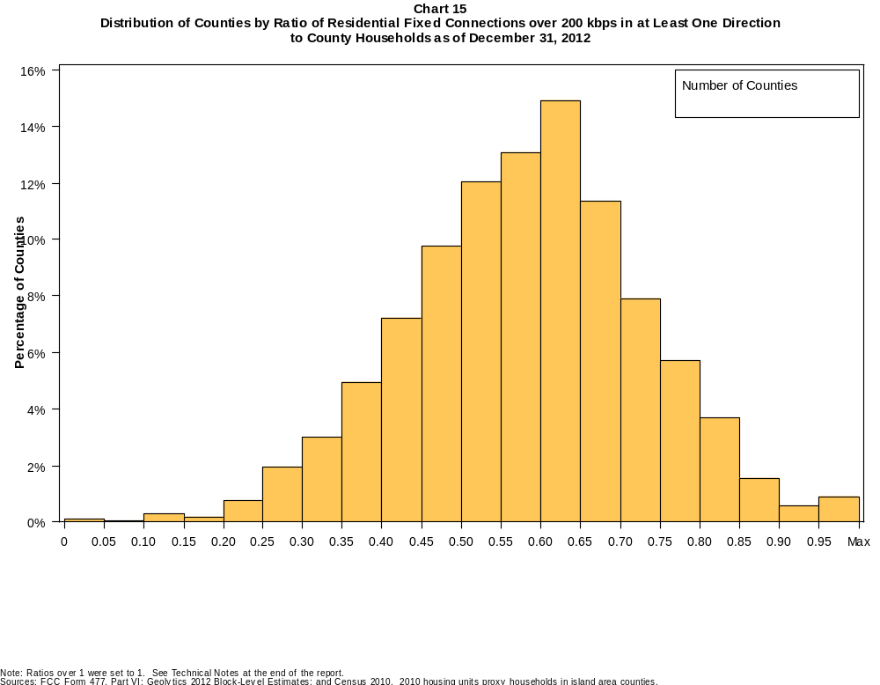

Table 22
Distribution of Counties by Ratio of Residential Fixed Connections over 200 kbps in at Least One Direction
to County Households by Technology as of December 31, 2012

 | Ratio of Residential Fixed Connections to County Households
Technology | Zero | Greater than 0 and no more than 5% | Greater than 5 and no more than 10% | Greater than 10 and no more than 20% | Greater than 20 and no more than 30% | Greater than 30 and no more than 40% | Greater than 40 and no more than 50% | Greater than 50 and no more than 60% | Greater than 60 and no more than 80% | Greater than 80 and no more than 100% | 100% or more
aDSL | 0.5 | 2.1 | 5.2 | 25.8 | 30.7 | 21.3 | 9.2 | 3.6 | 1.3 | 0.3 | 0.1
sDSL | 83.1 | 16.2 | 0.3 | 0.2 | 0.1 | 0.0 | 0.0 | 0.0 | 0.0 | 0.0 | 0.0
Other Wireline | 96.8 | 3.0 | 0.0 | 0.0 | 0.0 | 0.0 | 0.0 | 0.0 | 0.0 | 0.0 | 0.0
Cable Modem | 12.7 | 8.8 | 9.1 | 17.9 | 16.9 | 14.9 | 11.6 | 5.4 | 2.4 | 0.3 | 0.1
FTTP | 55.3 | 30.7 | 4.8 | 4.0 | 2.4 | 1.4 | 0.6 | 0.4 | 0.5 | 0.0 | 0.0
Satellite | 0.7 | 76.5 | 17.1 | 5.3 | 0.3 | 0.1 | 0.0 | 0.0 | 0.0 | 0.0 | 0.0
Fixed Wireless | 41.9 | 44.6 | 8.4 | 4.1 | 0.7 | 0.2 | 0.0 | 0.1 | 0.0 | 0.0 | 0.0
Power Line | 100.0 | 0.0 | 0.0 | 0.0 | 0.0 | 0.0 | 0.0 | 0.0 | 0.0 | 0.0 | 0.0
All Other | 99.9 | 0.1 | 0.0 | 0.0 | 0.0 | 0.0 | 0.0 | 0.0 | 0.0 | 0.0 | 0.0
Total | 0.1 | 0.0 | 0.0 | 0.5 | 2.7 | 7.9 | 17.0 | 25.1 | 39.9 | 6.0 | 0.7

Note: Figures may not sum to totals due to rounding. See Technical Notes at the end of the report.
Sources: FCC Form 477, Part VI; Geolytics 2012 Block-Level Estimates; and Census 2010. 2010 housing units proxy households in island area counties.

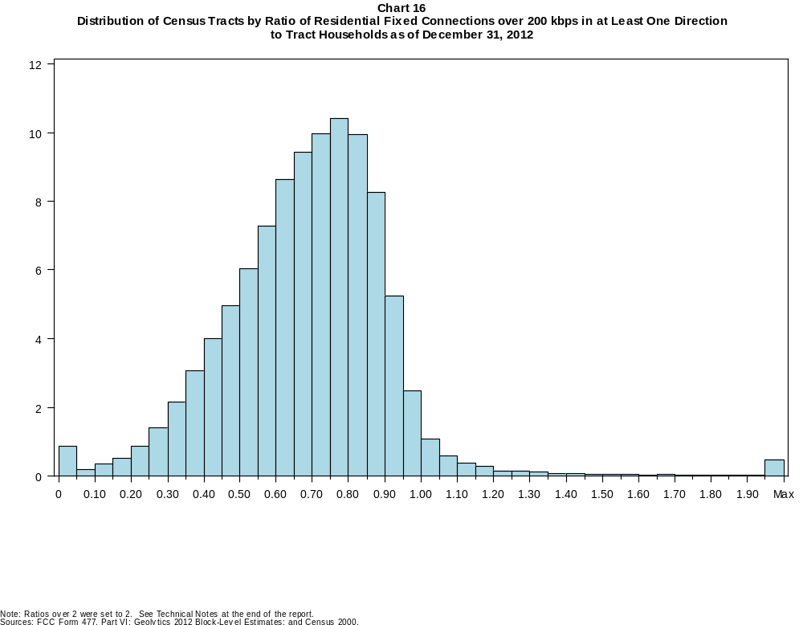

Table 23
Distribution of Census Tracts by Ratio of Residential Fixed Connections over 200 kbps in at Least One Direction
to Tract Households by Technology as of December 31, 2012

 | Ratio of Residential Fixed Connections to Tract Households
Technology | Zero | Greater than 0 and no more than 5% | Greater than 5 and no more than 10% | Greater than 10 and no more than 20% | Greater than 20 and no more than 30% | Greater than 30 and no more than 40% | Greater than 40 and no more than 50% | Greater than 50 and no more than 60% | Greater than 60 and no more than 80% | Greater than 80 and no more than 100% | 100% or more
aDSL | 1.4 | 9.2 | 11.1 | 27.6 | 23.4 | 15.0 | 7.5 | 2.9 | 1.3 | 0.3 | 0.3
sDSL | 96.6 | 3.2 | 0.1 | 0.1 | 0.0 | 0.0 | 0.0 | 0.0 | 0.0 | 0.0 | 0.0
Other Wireline | 99.7 | 0.2 | 0.0 | 0.0 | 0.0 | 0.0 | 0.0 | 0.0 | 0.0 | 0.0 | 0.0
Cable Modem | 5.7 | 3.3 | 2.4 | 7.8 | 14.5 | 18.5 | 17.7 | 14.2 | 13.1 | 2.0 | 0.9
FTTP | 72.3 | 11.1 | 2.0 | 3.1 | 3.2 | 3.6 | 2.6 | 1.3 | 0.6 | 0.1 | 0.1
Satellite | 35.3 | 57.6 | 4.4 | 2.2 | 0.4 | 0.1 | 0.0 | 0.0 | 0.0 | 0.0 | 0.0
Fixed Wireless | 83.2 | 13.1 | 1.8 | 1.3 | 0.4 | 0.1 | 0.1 | 0.0 | 0.0 | 0.0 | 0.0
Power Line | 99.9 | 0.1 | 0.0 | 0.0 | 0.0 | 0.0 | 0.0 | 0.0 | 0.0 | 0.0 | 0.0
All Other | 100.0 | 0.0 | 0.0 | 0.0 | 0.0 | 0.0 | 0.0 | 0.0 | 0.0 | 0.0 | 0.0
Total | 0.7 | 0.1 | 0.2 | 0.9 | 2.3 | 5.2 | 9.0 | 13.3 | 38.4 | 26.0 | 3.8

Note: Figures may not sum to totals due to rounding. See Technical Notes at the end of the report.
Sources: FCC Form 477, Part VI; Geolytics 2012 Block-Level Estimates; and Census 2000.

Table 24
Percentage of Census Tracts with Residential Fixed Connections by Technology as of December 31, 2012
(Connections over 200 kbps in at least one direction)

 | Number of Providers
Technology | Zero | One | Two | Three | Four | Five | Six | Seven or More
aDSL | 1.4 | 48.7 | 35.3 | 12.4 | 1.9 | 0.3 | 0.1 | 0.0
sDSL | 96.6 | 3.2 | 0.1 | 0.0 | 0.0 | 0.0 | 0.0 | 0.0
Other Wireline | 99.7 | 0.3 | 0.0 | 0.0 | 0.0 | 0.0 | 0.0 | 0.0
Cable Modem | 5.7 | 81.4 | 12.3 | 0.5 | 0.0 | 0.0 | 0.0 | 0.0
FTTP | 72.3 | 26.9 | 0.7 | 0.1 | 0.0 | 0.0 | 0.0 | 0.0
Satellite | 35.3 | 24.1 | 38.3 | 2.3 | 0.0 | 0.0 | 0.0 | 0.0
Fixed Wireless | 83.2 | 12.4 | 3.4 | 0.8 | 0.1 | 0.0 | 0.0 | 0.0
Power Line | 99.9 | 0.1 | 0.0 | 0.0 | 0.0 | 0.0 | 0.0 | 0.0
aDSL and/or Cable Modem and/or FTTP | 0.9 | 2.8 | 41.6 | 34.9 | 15.8 | 3.3 | 0.6 | 0.1
Any Technology | 0.7 | 0.5 | 14.1 | 23.7 | 28.6 | 18.7 | 8.6 | 5.0

Note: Figures may not sum to totals due to rounding. The number of providers in a census tract does not necessarily reflect the number of choices available to a particular household, and does not purport
to measure competition.
Sources: FCC Form 477, Part VI and Census 2010.

Table 25
Distribution of Counties by Ratio of Residential Fixed Connections to County Households by State as of December 31, 2012
(Connections over 200 kbps in at least one direction)

 |  | Ratio of Residential Fixed Connections over 200 kbps in at Least One Direction to County Households
State | Counties | Zero | Greater than 0 and no more than 5% | Greater than 5 and no more than 10% | Greater than 10 and no more than 20% | Greater than 20 and no more than 30% | Greater than 30 and no more than 40% | Greater than 40 and no more than 50% | Greater than 50 and no more than 60% | Greater than 60 and no more than 80% | Greater than 80 and no more than 100% | 100% or more
Alabama | 67 | 0 | 0 | 0 | 0 | 3 | 9 | 26 | 16 | 13 | 0 | 0
Alaska | 29 | 0 | 0 | 0 | 1 | 2 | 3 | 6 | 4 | 12 | 0 | 1
American Samoa | 5 | 2 | 1 | 0 | 1 | 1 | 0 | 0 | 0 | 0 | 0 | 0
Arizona | 15 | 0 | 0 | 0 | 0 | 0 | 1 | 1 | 4 | 9 | 0 | 0
Arkansas | 75 | 0 | 0 | 0 | 0 | 2 | 19 | 35 | 11 | 8 | 0 | 0
California | 58 | 0 | 0 | 0 | 1 | 0 | 2 | 1 | 9 | 35 | 9 | 1
Colorado | 64 | 0 | 0 | 0 | 0 | 1 | 0 | 3 | 19 | 24 | 11 | 6
Connecticut | 8 | 0 | 0 | 0 | 0 | 0 | 0 | 0 | 0 | 4 | 4 | 0
Delaware | 3 | 0 | 0 | 0 | 0 | 0 | 0 | 0 | 0 | 2 | 1 | 0
District of Columbia | 1 | 0 | 0 | 0 | 0 | 0 | 0 | 0 | 0 | 1 | 0 | 0
Florida | 67 | 0 | 0 | 0 | 0 | 3 | 0 | 11 | 10 | 32 | 10 | 1
Georgia | 159 | 0 | 0 | 0 | 1 | 10 | 15 | 36 | 40 | 49 | 8 | 0
Guam | 1 | 0 | 0 | 0 | 0 | 0 | 0 | 0 | 0 | 1 | 0 | 0
Hawaii | 5 | 0 | 0 | 0 | 0 | 0 | 0 | 0 | 0 | 3 | 2 | 0
Idaho | 44 | 0 | 0 | 1 | 0 | 1 | 4 | 6 | 11 | 18 | 2 | 1
Illinois | 102 | 0 | 0 | 0 | 1 | 2 | 4 | 14 | 35 | 40 | 3 | 3
Indiana | 92 | 0 | 0 | 0 | 0 | 0 | 5 | 15 | 42 | 28 | 2 | 0
Iowa | 99 | 0 | 0 | 0 | 0 | 0 | 0 | 4 | 34 | 60 | 1 | 0
Kansas | 105 | 0 | 0 | 0 | 0 | 0 | 1 | 13 | 26 | 54 | 11 | 0
Kentucky | 120 | 0 | 0 | 0 | 0 | 2 | 7 | 28 | 38 | 44 | 1 | 0
Louisiana | 64 | 0 | 0 | 0 | 0 | 1 | 11 | 14 | 21 | 17 | 0 | 0
Maine | 16 | 0 | 0 | 0 | 0 | 0 | 0 | 0 | 2 | 12 | 2 | 0
Maryland | 24 | 0 | 0 | 0 | 0 | 0 | 0 | 4 | 1 | 14 | 5 | 0
Massachusetts | 14 | 0 | 0 | 0 | 0 | 0 | 0 | 0 | 0 | 7 | 4 | 3
Michigan | 83 | 0 | 0 | 0 | 0 | 2 | 5 | 11 | 26 | 37 | 2 | 0
Minnesota | 87 | 0 | 0 | 0 | 0 | 0 | 1 | 3 | 23 | 58 | 2 | 0
Mississippi | 82 | 0 | 0 | 0 | 0 | 11 | 35 | 19 | 11 | 6 | 0 | 0
Missouri | 115 | 0 | 0 | 0 | 1 | 3 | 10 | 36 | 38 | 26 | 1 | 0
Montana | 56 | 0 | 0 | 0 | 0 | 1 | 0 | 8 | 13 | 33 | 1 | 0
Nebraska | 93 | 0 | 0 | 0 | 0 | 0 | 5 | 10 | 28 | 49 | 1 | 0

Table 25 - Continued
Distribution of Counties by Ratio of Residential Fixed Connections to County Households by State as of December 31, 2012
(Connections over 200 kbps in at least one direction)

 |  | Ratio of Residential Fixed Connections over 200 kbps in at Least One Direction to County Households
State | Counties | Zero | Greater than 0 and no more than 5% | Greater than 5 and no more than 10% | Greater than 10 and no more than 20% | Greater than 20 and no more than 30% | Greater than 30 and no more than 40% | Greater than 40 and no more than 50% | Greater than 50 and no more than 60% | Greater than 60 and no more than 80% | Greater than 80 and no more than 100% | 100% or more
Nevada | 17 | 0 | 0 | 0 | 0 | 0 | 3 | 3 | 3 | 8 | 0 | 0
New Hampshire | 10 | 0 | 0 | 0 | 0 | 0 | 0 | 0 | 0 | 5 | 5 | 0
New Jersey | 21 | 0 | 0 | 0 | 0 | 0 | 0 | 0 | 0 | 11 | 9 | 1
New Mexico | 33 | 0 | 0 | 0 | 0 | 1 | 6 | 6 | 10 | 8 | 2 | 0
New York | 62 | 0 | 0 | 0 | 0 | 0 | 0 | 0 | 4 | 46 | 11 | 1
North Carolina | 100 | 0 | 0 | 0 | 0 | 0 | 3 | 19 | 28 | 36 | 13 | 1
North Dakota | 53 | 0 | 0 | 0 | 0 | 0 | 0 | 4 | 6 | 38 | 4 | 1
Northern Mariana Isl | 4 | 1 | 0 | 0 | 3 | 0 | 0 | 0 | 0 | 0 | 0 | 0
Ohio | 88 | 0 | 0 | 0 | 0 | 0 | 1 | 8 | 23 | 53 | 3 | 0
Oklahoma | 77 | 0 | 0 | 0 | 0 | 4 | 13 | 27 | 18 | 14 | 1 | 0
Oregon | 36 | 0 | 0 | 0 | 0 | 0 | 0 | 3 | 10 | 21 | 2 | 0
Pennsylvania | 67 | 0 | 0 | 0 | 0 | 0 | 1 | 2 | 11 | 40 | 12 | 1
Puerto Rico | 78 | 0 | 0 | 0 | 0 | 14 | 20 | 31 | 11 | 2 | 0 | 0
Rhode Island | 5 | 0 | 0 | 0 | 0 | 0 | 0 | 0 | 0 | 4 | 1 | 0
South Carolina | 46 | 0 | 0 | 0 | 0 | 0 | 10 | 8 | 13 | 12 | 3 | 0
South Dakota | 66 | 0 | 0 | 0 | 0 | 1 | 1 | 7 | 10 | 43 | 4 | 0
Tennessee | 95 | 0 | 0 | 0 | 1 | 3 | 12 | 35 | 29 | 14 | 1 | 0
Texas | 254 | 0 | 0 | 0 | 1 | 6 | 29 | 58 | 77 | 73 | 9 | 1
Utah | 29 | 0 | 0 | 0 | 0 | 1 | 1 | 1 | 5 | 16 | 4 | 1
Vermont | 14 | 0 | 0 | 0 | 0 | 0 | 0 | 0 | 1 | 7 | 6 | 0
Virgin Islands | 3 | 0 | 0 | 0 | 0 | 0 | 2 | 0 | 1 | 0 | 0 | 0
Virginia | 134 | 0 | 0 | 0 | 4 | 12 | 13 | 17 | 41 | 32 | 14 | 1
Washington | 39 | 0 | 0 | 0 | 0 | 1 | 2 | 0 | 9 | 27 | 0 | 0
West Virginia | 55 | 0 | 0 | 0 | 0 | 0 | 3 | 11 | 20 | 20 | 1 | 0
Wisconsin | 72 | 0 | 0 | 0 | 0 | 0 | 0 | 2 | 14 | 52 | 4 | 0
Wyoming | 23 | 0 | 0 | 0 | 0 | 0 | 0 | 4 | 5 | 13 | 1 | 0
Total | 3,234 | 3 | 1 | 1 | 15 | 88 | 257 | 550 | 811 | 1291 | 193 | 24

Note: Figures may not sum to totals due to rounding. See Technical Notes at the end of the report.
Sources: FCC Form 477, Part VI (Connections); Geolytics 2012 Block-Level Estimates (Households for U.S. and District of Columbia); Census 2010 (Housing units for Puerto Rico, American Samoa,
Guam, Northern Mariana Islands and U.S. Virgin Islands).

Table 26
Distribution of Census Tracts by Ratio of Residential Fixed Connections to Tract Households by State as of December 31, 2012
(Connections over 200 kbps in at least one direction)

 |  | Ratio of Residential Fixed Connections over 200 kbps in at Least One Direction to Tract Households
State | Tracts | Zero | Greater than 0 and no more than 5% | Greater than 5 and no more than 10% | Greater than 10 and no more than 20% | Greater than 20 and no more than 30% | Greater than 30 and no more than 40% | Greater than 40 and no more than 50% | Greater than 50 and no more than 60% | Greater than 60 and no more than 80% | Greater than 80 and no more than 100% | 100% or more
Alabama | 1,179 | 5 | 2 | 1 | 13 | 80 | 164 | 255 | 207 | 329 | 103 | 20
Alaska | 167 | 2 | 0 | 2 | 4 | 8 | 8 | 15 | 27 | 72 | 18 | 11
American Samoa | 18 | 3 | 6 | 1 | 1 | 2 | 1 | 2 | 0 | 1 | 1 | 0
Arizona | 1,526 | 20 | 9 | 9 | 17 | 23 | 60 | 121 | 181 | 537 | 461 | 88
Arkansas | 686 | 2 | 1 | 1 | 13 | 63 | 113 | 156 | 125 | 167 | 36 | 9
California | 8,036 | 53 | 10 | 13 | 37 | 72 | 177 | 418 | 736 | 3,025 | 3,209 | 286
Colorado | 1,249 | 13 | 0 | 2 | 1 | 6 | 17 | 61 | 134 | 505 | 438 | 72
Connecticut | 829 | 3 | 0 | 0 | 0 | 2 | 12 | 39 | 57 | 290 | 405 | 21
Delaware | 215 | 1 | 0 | 0 | 1 | 0 | 1 | 17 | 24 | 78 | 76 | 17
District of Columbia | 179 | 1 | 0 | 0 | 0 | 0 | 3 | 16 | 31 | 77 | 39 | 12
Florida | 4,199 | 37 | 3 | 0 | 5 | 41 | 92 | 268 | 458 | 1,730 | 1,278 | 287
Georgia | 1,964 | 11 | 2 | 2 | 14 | 57 | 172 | 268 | 345 | 686 | 358 | 49
Guam | 56 | 6 | 0 | 1 | 3 | 2 | 0 | 2 | 2 | 3 | 4 | 33
Hawaii | 326 | 11 | 0 | 1 | 2 | 0 | 3 | 8 | 21 | 124 | 114 | 42
Idaho | 298 | 0 | 0 | 1 | 2 | 3 | 17 | 23 | 77 | 147 | 23 | 5
Illinois | 3,121 | 9 | 3 | 1 | 20 | 45 | 191 | 328 | 473 | 1,291 | 690 | 70
Indiana | 1,508 | 5 | 2 | 2 | 7 | 15 | 67 | 235 | 370 | 598 | 195 | 12
Iowa | 825 | 2 | 1 | 0 | 1 | 4 | 13 | 62 | 177 | 475 | 81 | 9
Kansas | 770 | 9 | 0 | 0 | 3 | 13 | 38 | 78 | 141 | 326 | 134 | 28
Kentucky | 1,115 | 12 | 0 | 1 | 8 | 31 | 74 | 155 | 237 | 428 | 145 | 24
Louisiana | 1,136 | 14 | 0 | 0 | 7 | 40 | 128 | 191 | 228 | 391 | 114 | 23
Maine | 351 | 0 | 0 | 0 | 1 | 1 | 3 | 20 | 35 | 194 | 80 | 17
Maryland | 1,394 | 7 | 0 | 0 | 2 | 15 | 68 | 87 | 110 | 484 | 568 | 53
Massachusetts | 1,471 | 11 | 0 | 0 | 2 | 1 | 5 | 34 | 84 | 534 | 727 | 73
Michigan | 2,767 | 29 | 1 | 1 | 22 | 96 | 231 | 298 | 376 | 1,096 | 594 | 23
Minnesota | 1,335 | 4 | 2 | 1 | 1 | 8 | 25 | 77 | 219 | 705 | 280 | 13
Mississippi | 661 | 4 | 0 | 2 | 10 | 80 | 161 | 120 | 109 | 135 | 34 | 6
Missouri | 1,393 | 6 | 1 | 4 | 8 | 77 | 123 | 183 | 266 | 485 | 214 | 26
Montana | 271 | 2 | 2 | 1 | 3 | 4 | 4 | 22 | 61 | 132 | 32 | 8
Nebraska | 532 | 2 | 0 | 0 | 0 | 0 | 16 | 48 | 102 | 244 | 105 | 15

Table 26 - Continued
Distribution of Census Tracts by Ratio of Residential Fixed Connections to Tract Households by State as of December 31, 2012
(Connections over 200 kbps in at least one direction)

 |  | Ratio of Residential Fixed Connections over 200 kbps in at Least One Direction to Tract Households
State | Tracts | Zero | Greater than 0 and no more than 5% | Greater than 5 and no more than 10% | Greater than 10 and no more than 20% | Greater than 20 and no more than 30% | Greater than 30 and no more than 40% | Greater than 40 and no more than 50% | Greater than 50 and no more than 60% | Greater than 60 and no more than 80% | Greater than 80 and no more than 100% | 100% or more
Nevada | 683 | 6 | 0 | 0 | 10 | 16 | 34 | 72 | 79 | 301 | 141 | 24
New Hampshire | 294 | 2 | 0 | 0 | 1 | 0 | 0 | 1 | 10 | 113 | 158 | 9
New Jersey | 2,004 | 9 | 1 | 0 | 2 | 1 | 6 | 27 | 106 | 770 | 987 | 95
New Mexico | 499 | 3 | 11 | 5 | 8 | 19 | 55 | 73 | 92 | 167 | 52 | 14
New York | 4,900 | 73 | 0 | 2 | 21 | 19 | 66 | 142 | 330 | 2,213 | 1,795 | 239
North Carolina | 2,183 | 19 | 1 | 0 | 4 | 38 | 106 | 263 | 360 | 730 | 448 | 214
North Dakota | 205 | 0 | 0 | 0 | 0 | 1 | 4 | 15 | 29 | 110 | 35 | 11
Northern Mariana Isl | 22 | 3 | 1 | 1 | 1 | 2 | 1 | 0 | 3 | 0 | 1 | 9
Ohio | 2,946 | 7 | 0 | 1 | 8 | 47 | 164 | 281 | 476 | 1,244 | 633 | 85
Oklahoma | 1,046 | 1 | 6 | 5 | 33 | 72 | 121 | 170 | 188 | 279 | 145 | 26
Oregon | 827 | 2 | 0 | 0 | 1 | 1 | 9 | 34 | 118 | 475 | 178 | 9
Pennsylvania | 3,217 | 22 | 1 | 4 | 23 | 27 | 57 | 186 | 461 | 1,444 | 841 | 151
Puerto Rico | 903 | 14 | 3 | 22 | 157 | 176 | 163 | 118 | 83 | 64 | 33 | 70
Rhode Island | 241 | 1 | 0 | 0 | 1 | 0 | 0 | 2 | 16 | 140 | 77 | 4
South Carolina | 1,097 | 10 | 0 | 0 | 9 | 41 | 115 | 172 | 179 | 328 | 166 | 77
South Dakota | 222 | 0 | 1 | 0 | 1 | 2 | 8 | 9 | 33 | 131 | 34 | 3
Tennessee | 1,497 | 21 | 2 | 2 | 12 | 76 | 177 | 278 | 306 | 456 | 149 | 18
Texas | 5,253 | 39 | 9 | 25 | 81 | 243 | 539 | 753 | 773 | 1,558 | 1,025 | 208
Utah | 588 | 5 | 2 | 3 | 1 | 3 | 5 | 21 | 60 | 298 | 156 | 34
Vermont | 184 | 1 | 0 | 0 | 0 | 0 | 1 | 1 | 11 | 101 | 54 | 15
Virgin Islands | 29 | 0 | 0 | 1 | 3 | 4 | 3 | 2 | 4 | 3 | 3 | 6
Virginia | 1,895 | 22 | 2 | 5 | 38 | 63 | 101 | 164 | 224 | 482 | 706 | 88
Washington | 1,446 | 2 | 1 | 2 | 6 | 14 | 28 | 78 | 151 | 690 | 448 | 26
West Virginia | 484 | 0 | 1 | 4 | 13 | 19 | 36 | 56 | 88 | 184 | 62 | 21
Wisconsin | 1,393 | 3 | 2 | 1 | 5 | 13 | 65 | 102 | 218 | 723 | 242 | 19
Wyoming | 132 | 1 | 0 | 0 | 1 | 4 | 3 | 12 | 18 | 69 | 21 | 3
Total | 73,767 | 550 | 89 | 130 | 648 | 1,690 | 3,854 | 6,639 | 9,829 | 28,362 | 19,146 | 2,830

Note: Figures may not sum to totals due to rounding. See Technical Notes at the end of the report.
Sources: FCC Form 477, Part VI (Connections); Geolytics 2012 Block-Level Estimates (Households for U.S. and District of Columbia); Census 2000 (Households for Puerto Rico, American Samoa,
Guam, Northern Mariana Islands and U.S. Virgin Islands).

